OpenDRAC Web Client User Guide

|  |  |
| --- | --- |
| Author: | André van der Ark |
| Version: | 0.1 |
| Date: | 21-11-2011 |
|  |  |
|  |  |

Table of Contents

1 Introduction 3

2 OpenDRAC 4

2.1 Dynamic light paths 4

2.2 Schedules and Services 4

2.3 User Management 5

3 Web Client 7

3.1 Menu General 7

3.2 Menu Schedule 14

3.3 Menu Service 25

3.4 Menu Network 30

3.5 Menu Messages 35

3.6 Menu Management 40

3.7 Menu Help 65

4 Use Cases 69

4.1 Scheduling a service 69

4.2 Setting up a simple user hierarchy 70

# Introduction

OpenDRAC is an open source project that aims to create a state-of-the-art piece of middle ware that allows network control by users and applications. It aims to be compatible with open standards, and where these don't exist it wants to be an appropriate proving ground.

The Dynamic Resource Allocation Controller, or OpenDRAC for short, is an implementation of a grid-like resource broker providing end application control of network resources. The primary goal of OpenDRAC is to expose network bandwidth to end user/application control while preventing unauthorized access and resource theft. OpenDRAC is capable of providing an application with bandwidth-on-demand, as well as guaranteed reservation of bandwidth for utilization at a later point in time. To this goal OpenDRAC offers the possibility to schedule services.

Originally conceived and prototyped back in 2000 by the Nortel Advanced Technology organization under the name CO2 (Content Over Optical), OpenDRAC was specifically designed to control hybrid Ethernet/optical networks for high-bandwidth scientific applications and storage area networks.

Production of OpenDRAC began in 2005 when SURFnet bv requested a deployable solution for their new SURFnet6 hybrid network. Development of the OpenDRAC product was then taken over by the Nortel Metro Ethernet Networks (MEN) organization, where support for the product continues today.

This document is the manual of the web client. The manual for the, admin console, automation tool and the web services of OpenDRAC are contained by the downloadable archives.

# OpenDRAC

This chapter describes some general paradigms of OpenDRAC.

## Dynamic light paths

Besides the standard routed IP-network SURFnet offers optical connections between two points. These are called light paths. Light paths offer high bandwidth (up to 10Gb/s) at high reliability. For one, this reliability is so high because a backup path is created for each light path. This backup takes over if the primary path fails.

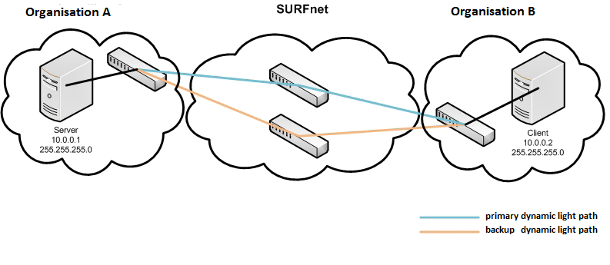

Figure 1: Light path between two organisations

SURFnet already uses static light paths in its network for high standard research tasks, but e.g. also for periodically creating backups. These light paths set up a connection between two points, e.g. two universities.

Dynamic light paths enable end users to temporarily set up a light path themselves. These paths can be with other users in the network of SURFnet. Once they’ve gotten the availability over resources, they can use these to their liking. This can be done with OpenDRAC.

## Schedules and Services

The primary goal of OpenDRAC is to enable users to temporarily reserve bandwidth on dedicated “lines” between two end points. At creation of the reservation the path between the two end points is computated and it is this physical path that is claimed during execution of the reservation.

A reservation is made as a schedule. A schedule has a duration and can repeat periodically. E.g. you can create a schedule that reserves 1000Mbit/sec between two endpoints every Monday between 12:00h and 13:00h for the coming year.

When a schedule is created one or more services are made, depending on the number of repetitions. It is this service that makes the actual reservation on the network.

A service can be altered after creation, provided it's start date is in the future. Changing a service does not alter the schedule or any other service that is created with the schedule. It is also possible to create a new service using a schedule as a template. Such a service is then added to the list of services derived from the schedule.

## User Management

OpenDRAC has an elaborate hierarchy for user management. This hierarchy consists of user groups, resource groups and users. The hierarchy is built up as follows:

* For an organization a parent resource group is set up. The parent resource group may contain zero or more resource groups and a resource group may contain zero or more resources. A resource is typically a termination point for a light path.
* A resource group can contain zero or more user groups. The user group has access to the resources of the associated resource group.
* A user group can contain zero or more users.

To control the set of actions users can perform, multiple types of user groups haven are defined. There are three types of user groups:

1. User: Offers access to basic user capabilities through the system.
2. System Administrator: Offers access to all capabilities through the system.
3. Group Administrator: Offers access to basic user and group administrator capabilities through the system.

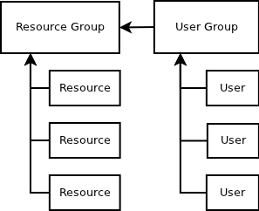

Figure 2: Simple schematic resource management

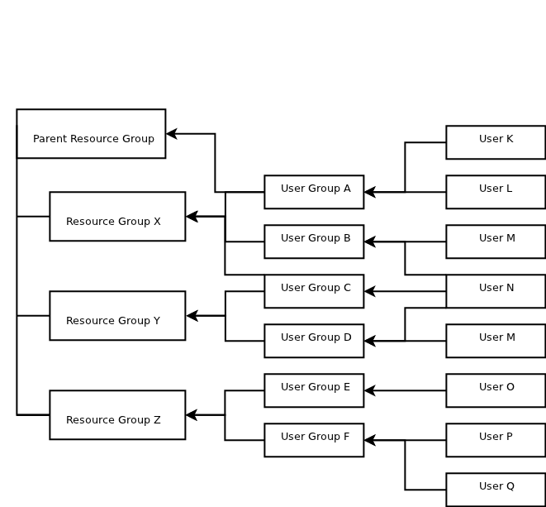

Figure 4: Schematic representation of hierarchical structure resource management

As depicted in the diagram above a user can be attached to multiple user groups and a user group can be attached to multiple resource groups.

# Web Client

OpenDRAC offers a web client. With this client the user can address the server of OpenDRAC to retrieve system data, provision dynamic light paths through schedules, maintain resource management, and send messages to other users. To use the web client the user must have a web browser and an internet connection.

The following paragraphs are a manual for using the web client.

## Menu General

The menu item “General” offers screens with general information of the server of OpenDRAC. This consists of server data, logged data and report generation. The following paragraphs give a detailed description of each menu item.

### Login

The first screen that is displayed when the web GUI is visited is the login screen. You can log in with the credentials that were provided to you by your administrator.

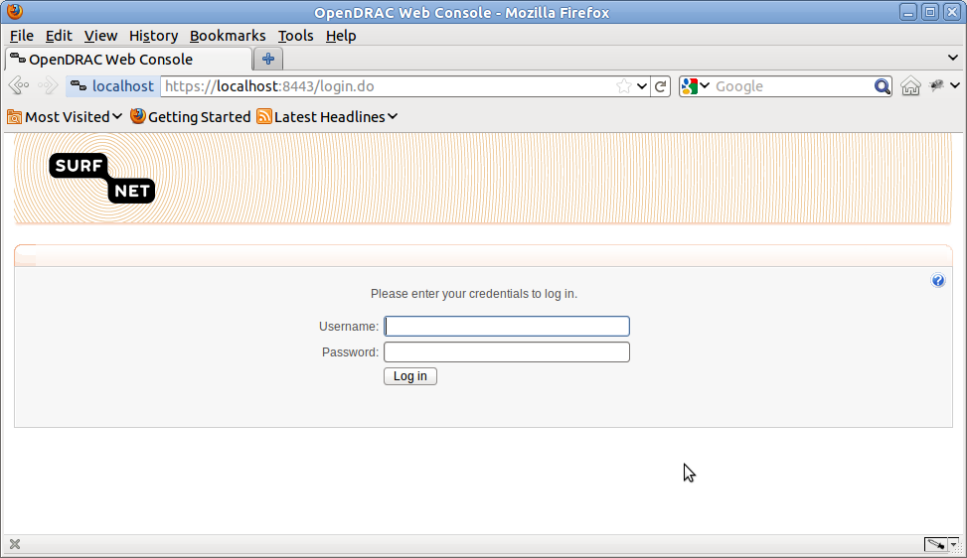

Figure 5: Login screen

### Welcome screen

After entering the right user name and password the landing page is displayed. This page displays a legal statement and some meta data about the current session.

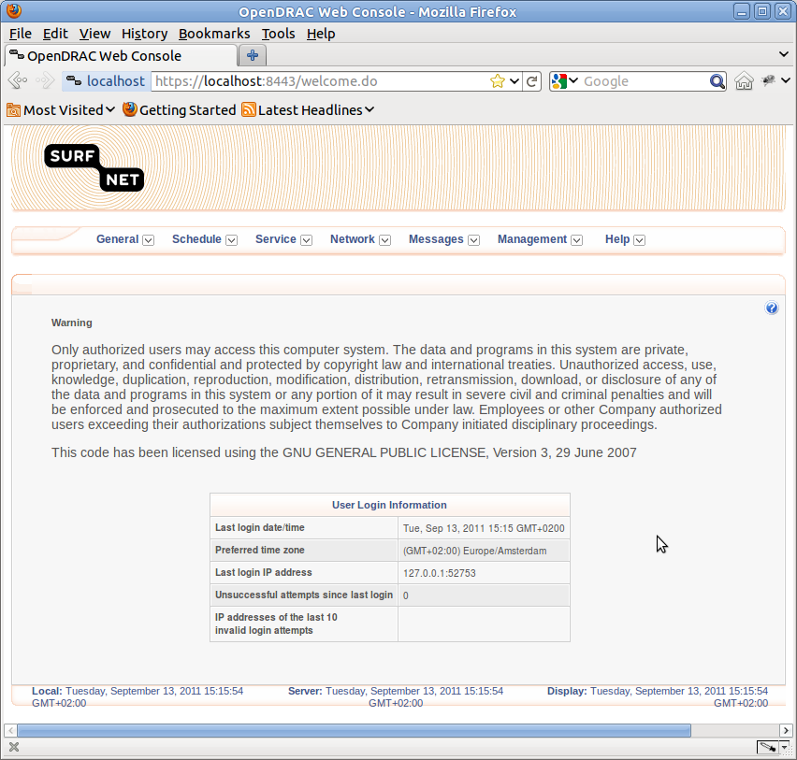

Figure 6: Landing page web client

### Server Status

From the menu-item: General → Server Status, the user can get an overview with meta data of the current server.

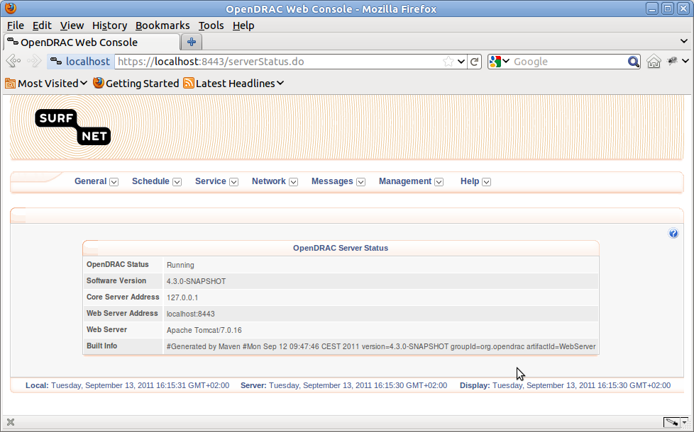

Figure 7: Server status

### Server settings

From the menu-item: General → Server Settings, the user can set two values for the server:

1. Pre - reservation confirmation time-out: With this field the user can set the maximum period for which the system will wait for confirmation about the availability of a requested light path. The default value for this field is 10 minutes.
2. Schedule provisioning overhead: The default value for this field is 10 milliseconds.

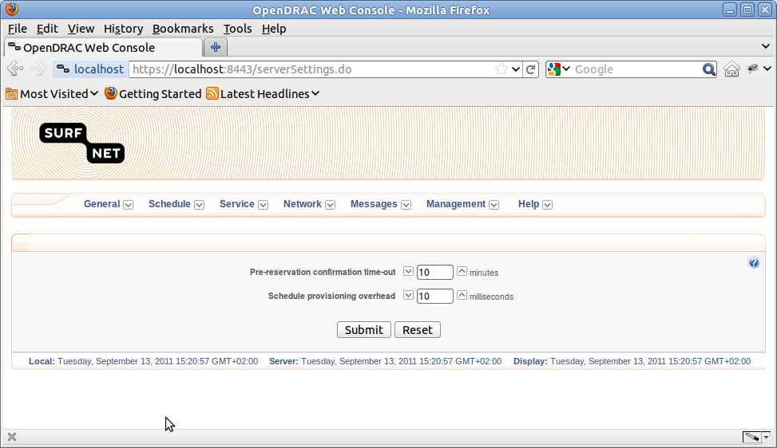

Figure 8: Server settings

### Audit Logs

From the menu-item: General → Audit Logs, the user can retrieve an overview of logged events.

To narrow down the displayed list of events to a series of events of interest, a form with filter options is provided. For each column in the table one or two filter options are available.

The available options are:

* Start Time: Start time for the requested log history.
* End Time: End time for the requested log history.
* Category: Subject type of logged event.
* Log Type: Event type of the logged event.
* Result: Result of the action for which the logging was done.
* Severity: The severity of the logged event, particularly for errors.
* IP Address: IP -address of the users that caused the logged events, as seen by OpenDRAC.
* Billing Group: Billing group of the user that cause the logged event.
* Resource: User name of the user that cause the logged event.

After retrieving clicking on the query button, the displayed results can be filtered with a mouse click on the name of the column to sort the results by.

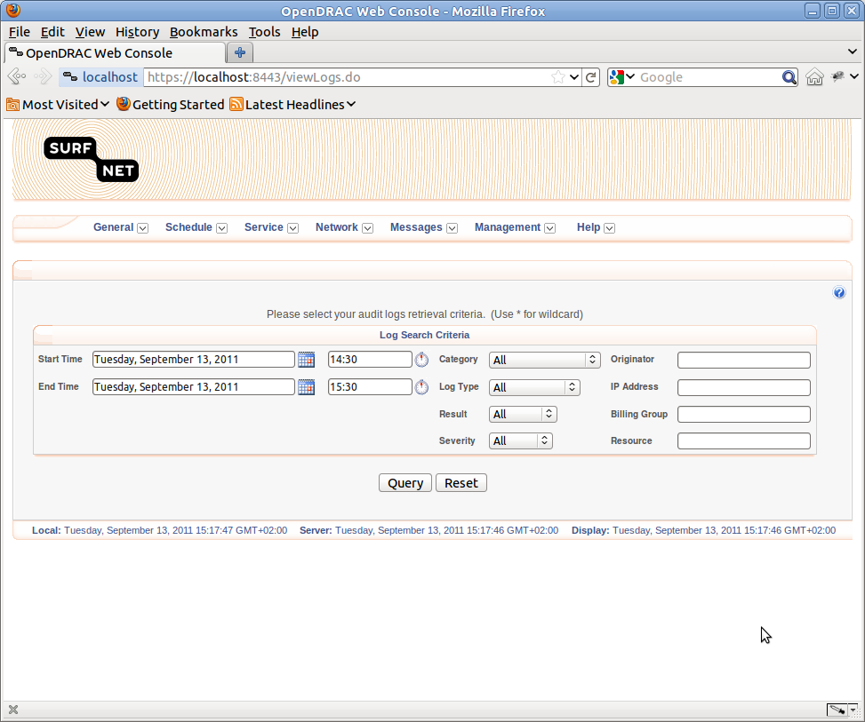

Figure 9: Form for retrieving audit logs

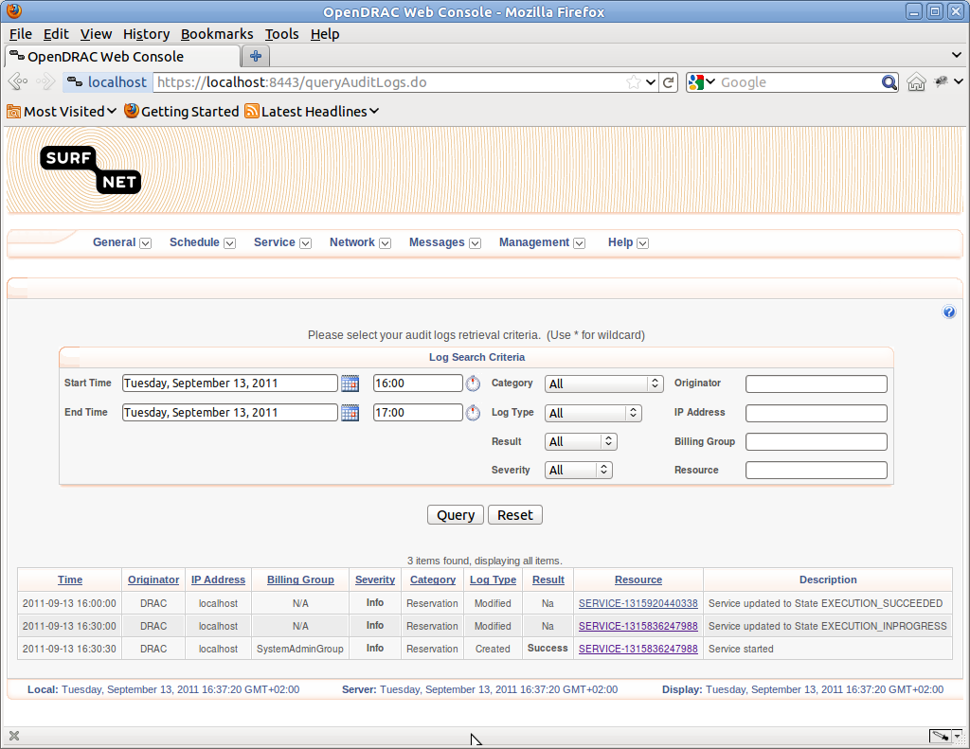

Figure 10: Form audit logs results

### Reporting

From the menu-item: General → Reporting, the user can generate reports. These reports can be displayed either on screen or downloaded in a character separated file. You can open such a file with a spread sheet program. The reports are generated for the given period of time.

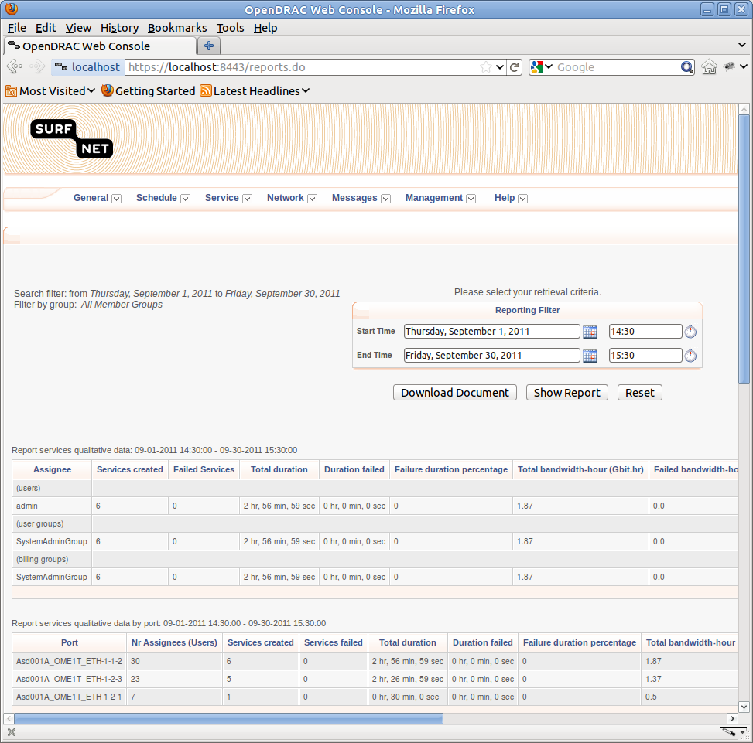

Figure 11: Reporting

A report consists of the following sub-reports:

* Report services qualitative data: This overview gives aggregated data by user, user group and billing group.
* Report services qualitative data by port: This overview gives aggregated data by termination point, i.e. port.
* Report scheduled services: This overview lists scheduled services.
* Report services: This overview lists services resulting from schedules.
* Report logged events: Because this overview can be very long, it is only available in the downloaded document. It gives an overview of all the events that were logged in the given period.

### Logout

To make sure no one can use OpenDRAC while you are away from your computer you can logout from the menu-item: General → Logout. After confirming logout you are logged out and the browser shows the login screen.

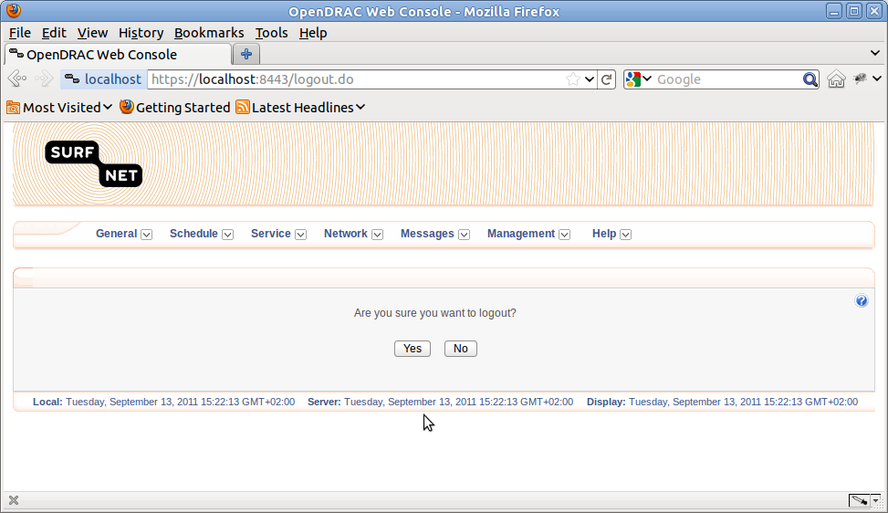

Figure 12: Logout

## Menu Schedule

The main goal of OpenDRAC is to schedule services for setting up light paths. This chapter describes the functionality dealing with schedules.

### List Schedules

From the menu item Schedule → List Schedules, an overview or registered schedules can be retrieved for a given period of time. If the schedules are currently running or scheduled somewhere in the future, the user can cancel these schedules. This is done by selecting the check boxes of the schedules and then click on the button “Confirm selected”.

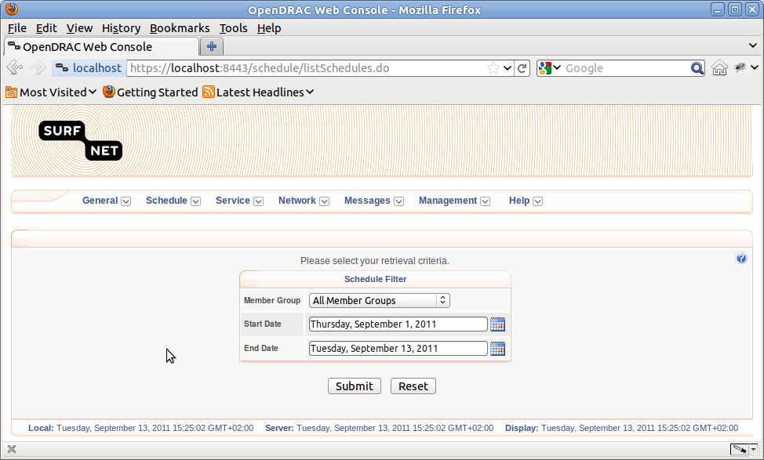

Figure 13: Form for retrieving list of schedules

This results in a list of schedules. If the schedule is not in the past it can be cancelled by checking the check box of the schedule and clicking of the button “cancel selected”.

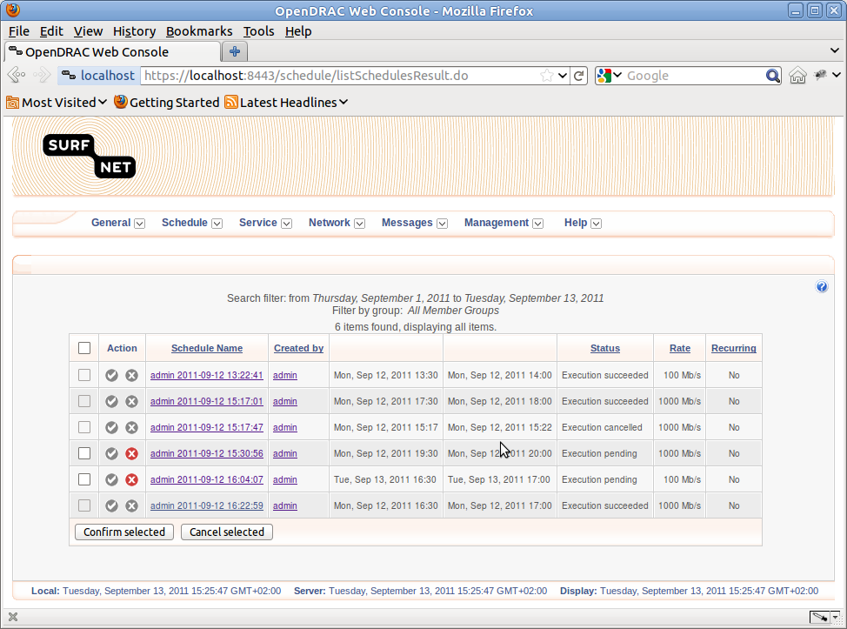Is the schedule is not yet completed or cancelled it can be cancelled with the button “Cancel Schedule”. If it was created as a pre-reservation and it's period settings are in the future it can be activated again with the button “Confirm Schedule”.

Figure 14: List of retrieved schedules

Clicking on the name of the schedule results in a screen with detailed information of that schedule. Below the schedule details, a list of resulting services is displayed. From this overview detailed service information can be retrieved by clicking on the name of the service.

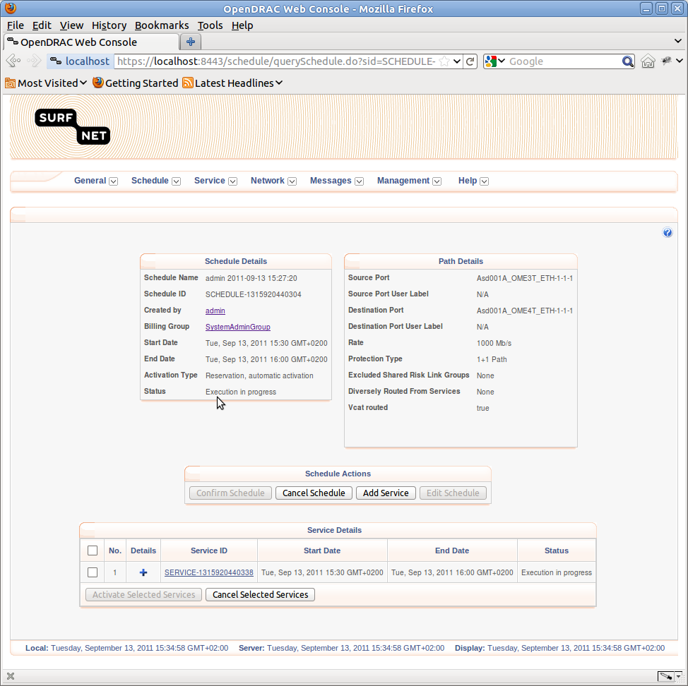

Figure 15: Schedule details

### Create Advanced Schedule

The main goal of OpenDRAC is to create scheduled services of light paths between two termination points. This can be done in the screen found under Schedule → Create Advanced Schedule.

This menu option leads to a big form for defining a schedule. The form consists of three blocks:

#### Schedule Information

In the block “Schedule Information” the following items can be entered:

* The name of the schedule.
* The activation type: This option offers the following values:
* Pre-reservation, automatic activation: The schedule is reserved, and is confirmed automatically at the given start time.
* Pre-reservation, manual activation: The schedule is reserved, but has to be confirmed. (via Schedule → List schedules).
* Reservation, automatic activation: The schedule is started automatically at the set start time.
* Reservation, manual activation: The schedule has to be activated manually (via Schedule → List schedules).
* The billing group: the group requesting the schedule.
* Start time, end time and consequently the duration of the schedule. The schedule can be started immediately by checking the check box in front of “start now”. By altering the end date the value in the duration field changes and vice versa.
* With the button “find a time” you can ask the server for an empty time slot for a particular light path. For this button to work, the fields source endpoint, destination endpoint, duration, and rate have to be filled in.

#### Light path Connectivity

In the block “Light path Connectivity” the following items can be entered:

* Source Endpoint: Definition of the source endpoint of the requested light path
* User Group: The user group for which the reservation is made. Because resource groups are linked to user groups, changing this field changes the list of values for the resource group.
* Resource Group: Resources (endpoints) are organized in resource groups. Setting the resource group changes the list of values for the endpoint.
* Site filter: end points can be grouped under a site, e.g. University Of Amsterdam.
* Endpoint: this list shows all the endpoints in the network elements connected to the server. If available, the logical name of is showed. If that is not available the physical name is shown. Changing the value in this selector changes the field value of physical name. The logical name can be set with the admin client.
* Endpoint Layer: choose from layer 0,1 or 2 (default). Changing this selector, changes the availability of the fields channel and vlan id.
* Endpoint channel: Only available for layer 1 connections. Indicates the channel within the chosen SDH or SONNET container.
* Endpoint VlanId: virtual LAN id the connection will be tagged with.
* Target Endpoint: Definition of the target endpoint of the requested light path. It has the same set of fields as the source end point.
* Rate: the bit rate of the requested light path in Mb/sec.
* Protection Type: either unprotected or 1+1 path protected. The latter sets up a redundant path that takes over if the set path fails.
* CCAT/VCAT: contiguous concatenation vs. virtual concatenation.

#### Optional Information

The block Optional Information consists of two tabs: Recurrence and Advance Options

Under the tab “Recurrence” you can define settings for repetitive schedules. It consists of the following fields:

* This schedule will repeat: make the schedule repetitive by checking this option.
* End after: either define the number of repetitions, or the end date for the schedule.
* Recurrence pattern: define whether the schedule should repeat daily, weekly, monthly or yearly.
* Under the tab “Advanced Options” you can set routing options and an email address. It consists of the following fields:
* E-mail address: for administrative purposes.
* Routing Algorithm: the algorithm that is used to create the path between source and target endpoint. The available options are:
* Default: Shortest Path First.
* Shortest Path First: Standard SPF.
* Constrained Shortest Path First: The same as Shortest Path First, but with extra settings that constrain the computation.
* CSPF Metric: Constrained Shorted Path First metric. This field is only active if for the routing algorithm “Constrained Shorted Path First ”.
* Default:
* Cost: Calculate by cost factors assigned to links.
* Hop: Minimise the amount of hops in the resulting route.
* Metric2: Value you can fill out with anything you want. For example, how "green" is a specific link so you can minimize on environmental impact.
* Metric value: The maximum for the chosen CSPF Metric. If only paths with a cost higher than the given value, the schedule is not created.
* Diversely routing options: With diverse routing, you can protect not only against cable failure but also against local exchange failure as there are two separate routes from two exchanges to your site. This option offers the following options:
* By shared risk link groups: Links can be grouped in a risk group. With the value given in this field you tell path computation which links to avoid at determining a new path. Fill in the name of the group.
* By Existing service ID: With the value given in this field you tell path computation which links to avoid at determining a new path, based on services that are active during the service period of the new schedule.

At the bottom of the form there are three buttons:

1. Query: query the server if the creation of the schedule is possible with the given parameters. Because this form has a lot of fields, it is advised to always first query the availability of the requested resources before clicking on the button “Create”.
2. Create: Create the schedule with the given parameters. If the requested resources are not available an error screen is displayed. It is advised to always first query the availability of the requested resources.
3. Reset: reset all form fields to their initial value.

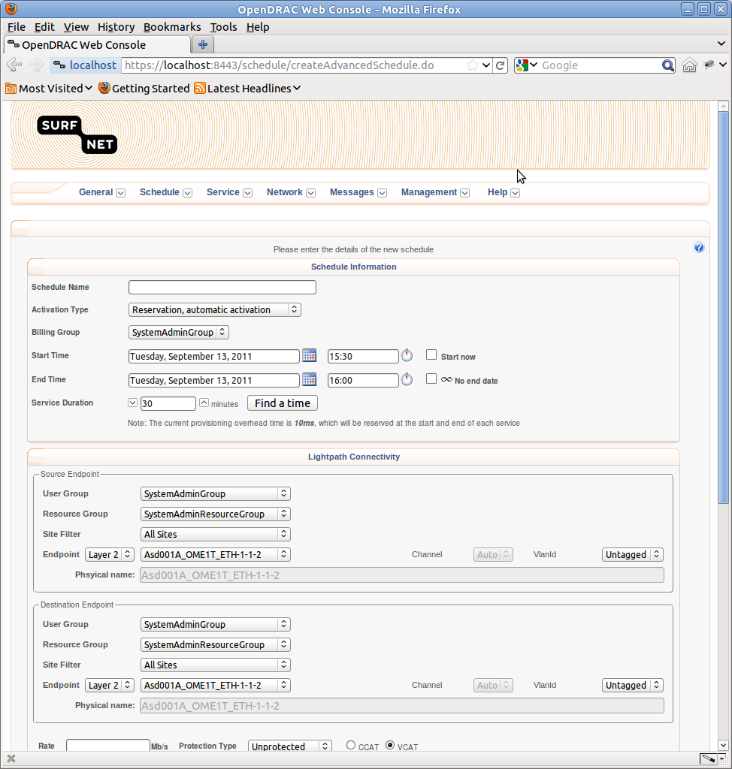

Figure 16: Form for creating a schedule

### Create Simple Schedule

From the menu item Schedule → List Create Schedule, a simplified form is displayed to create a schedule. Only the start- and end time for the schedule, duration, the termination points and the bit rate have to be entered.

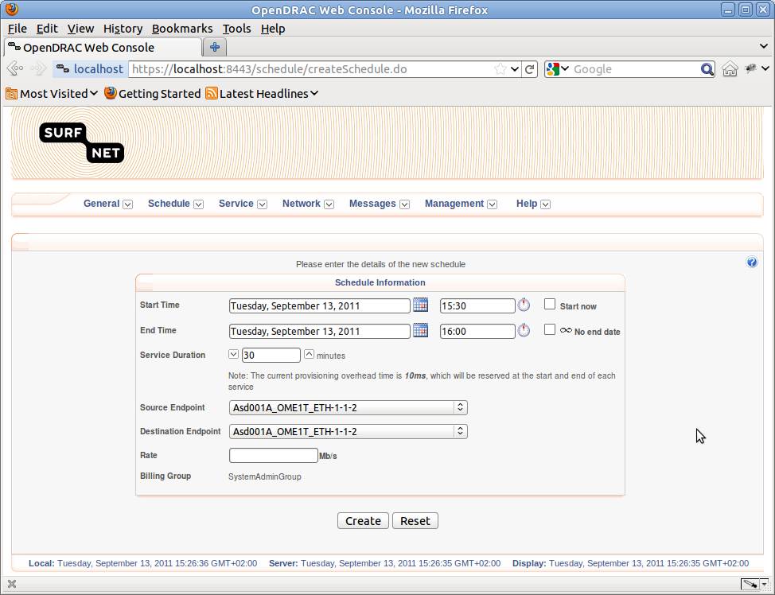

Figure 17: Simplified form for creating a schedule

Because this screen does not have the possibility to query for the availability of the requested resources, the results screen shows an error screen if it is not possible to create the schedule. To find an empty time slot for your schedule use the functionality under Schedule → Advanced Search.

Clicking on the button “Create” creates a new schedule, provided the requested resources are available. The schedule is then created with the given parameters and the default values for the other fields as presented in the normal Create Schedule.

NB: If a vlanId is required the schedule can only be created with the large create schedule form, as described in the previous paragraph.

### List Create Schedule Progress

From the menu item Schedule → List Create Schedule Progress, an overview of schedule creation in progress is displayed.

With the button “Clear Selected”, the selected schedules can be removed from the list.

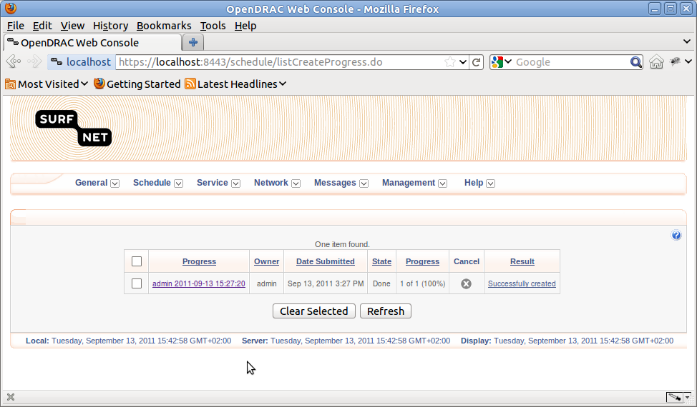

Figure 18: List create schedule progress

### Advanced Search

From the menu item Schedule → Advanced Search, the user can search time slots that are available to create a new schedule.

To do the search the following criteria must be entered:

* Source Port: Source port for which the availability of free time slots should be calculated.
* Destination Port: Displayed in a new window of this application.
* Duration: Duration of the schedule.
* Rate: Rate in Mb of the schedule.

After setting these values and clicking on the query button, a list with available time slots is displayed.

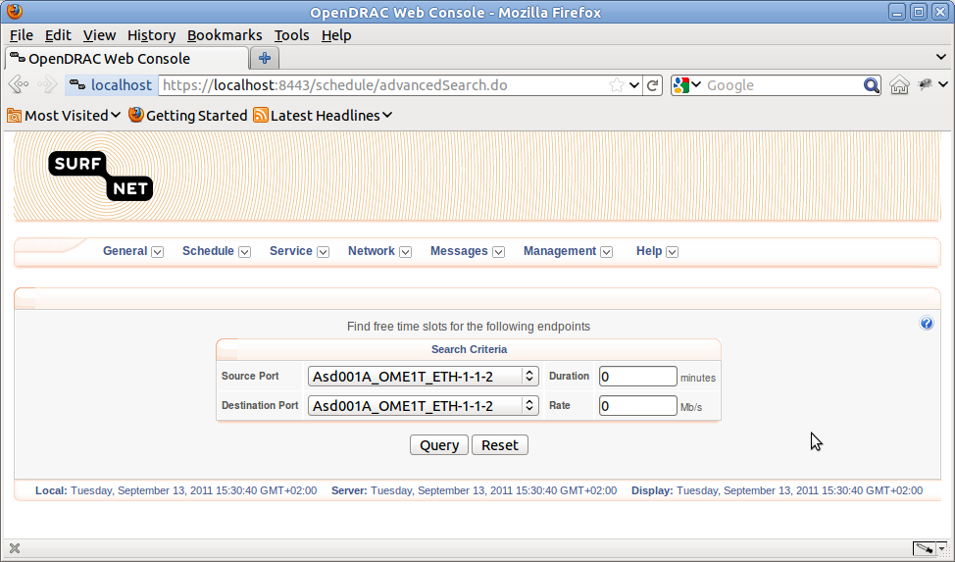

Figure 19: Advanced search form

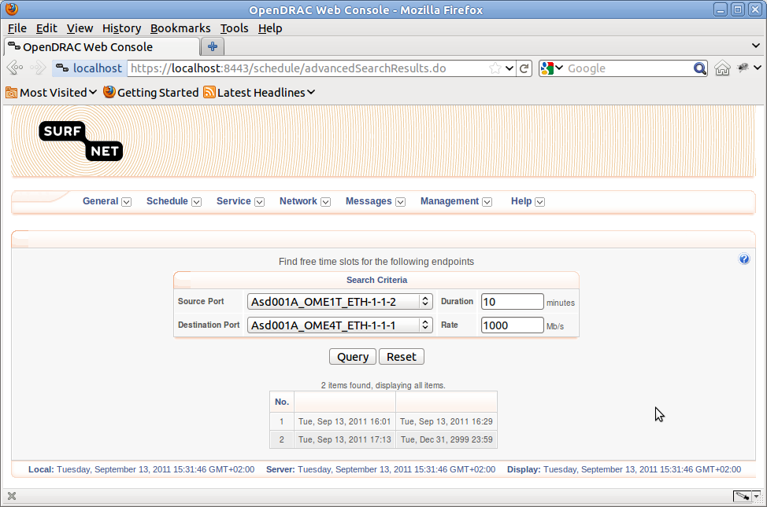

Figure 20: Advanced search results

## Menu Service

For each created schedule, depending on the repetition, at least one service is created. It is these services that set up the light paths. This chapter describes functionality dealing with services.

### List Services

From the menu item Service → List Services, the user can retrieve a series of services. By filling in the member group and start and end date a selection of services is retrieved from the server.

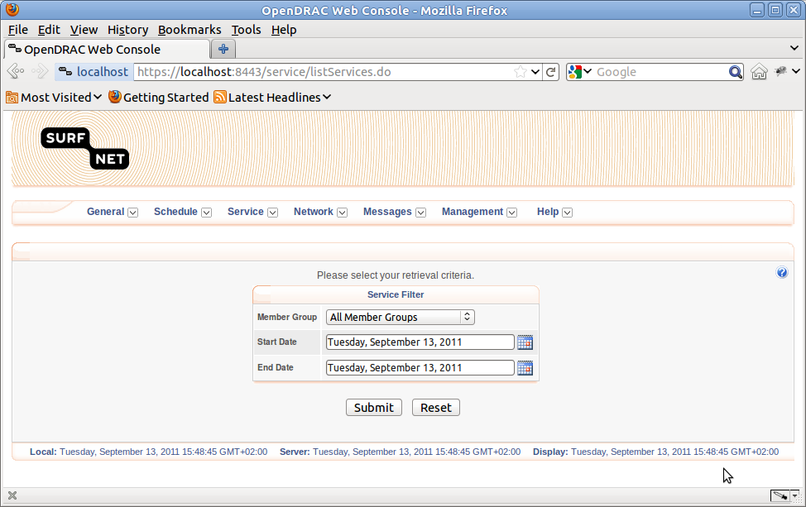After setting the values and clicking on the submit button a table with services is displayed. In this table the service name, schedule name and user name of the creator are links that lead to detail information of the service, schedule and user. The first cell of each table row holds a check box. Together with the two buttons at the bottom of the table you can perform actions on the selected services.

Figure 21: List services form

With the button “Activate Selected” you can reactivate a cancelled service.

With the button “Cancel Selected” you can cancel a service.

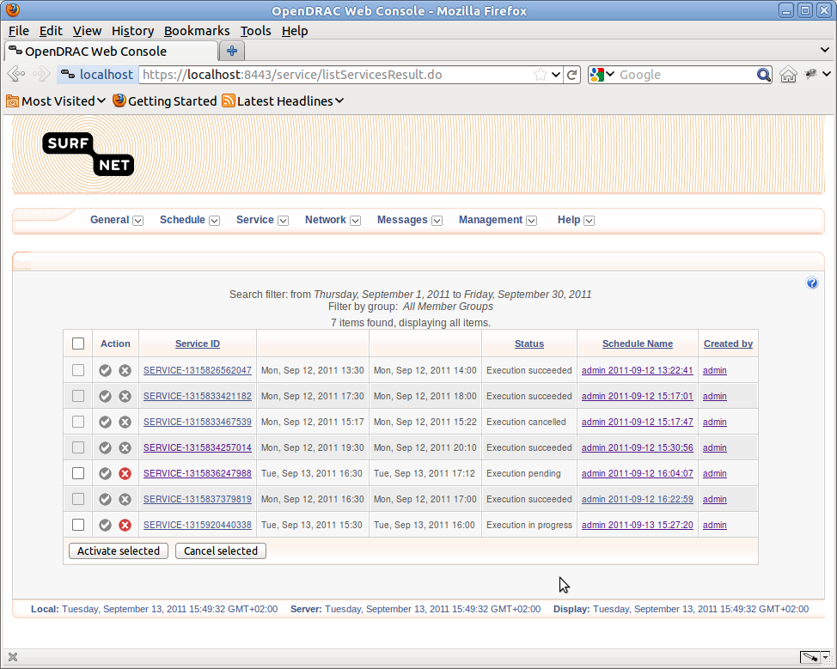

Figure 22: List services results

By clicking on the name of a service you are led to a screen with detailed information of the selected service. From this screen it is possible to extend the duration of that service. This is done by filling in the number of minutes to extend the service with and clicking on the button “extend”.

After clicking this button a little dialog with a progress bar pops up. If the action succeeds the dialog tells you by which amount of minutes the service has been extended. If there was an error, it is displayed in the same dialog.

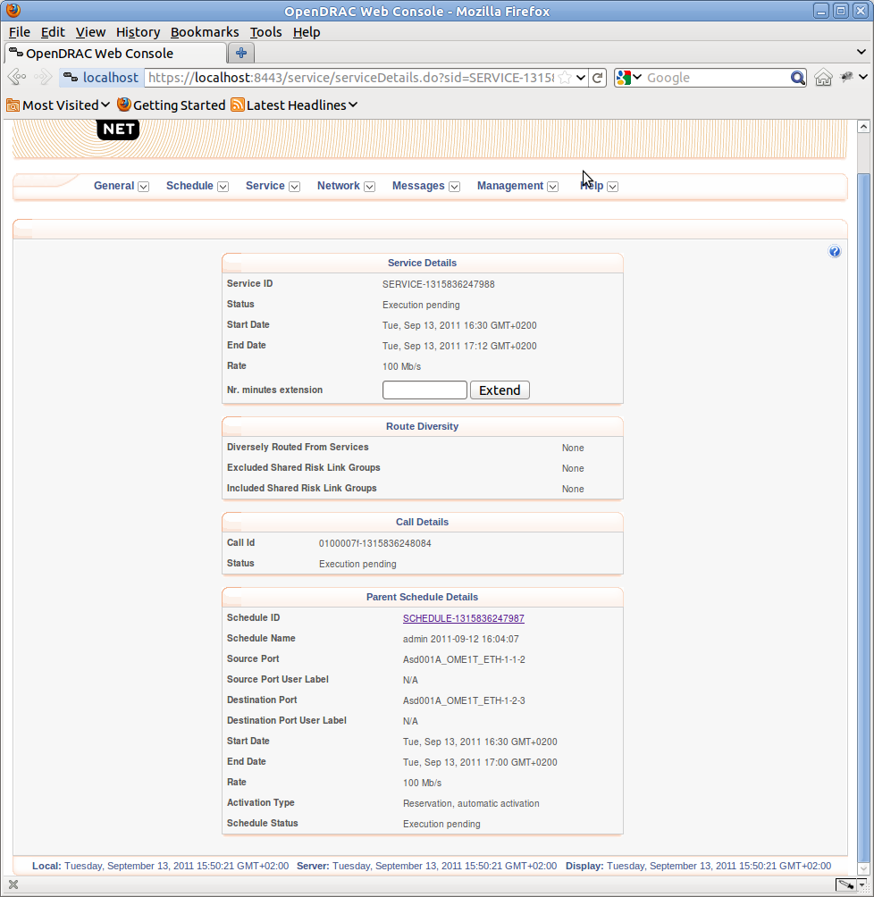

Figure 23: Service Details

### Add Service

From the menu item Service → Add Service, the user can add a service to a schedule. Selecting this menu option results in a list of schedules displayed in a table. By clicking on the plus-icon you can add a service.

To define the service the following fields have to be filled in.

1. Start time: the start time of the new service.
2. Stop Time: the end time of the new service.
3. Diversely Route By Shared Risk Link Groups: Links can be grouped in a risk group. With the value given in this field you tell path computation which links to avoid at determining a new path. Fill in the name of the group.
4. Diversely Route By Existing Services (ID): With the value given in this field you tell path computation which links to avoid at determining a new path, based on services that are active during the service period of the new schedule.

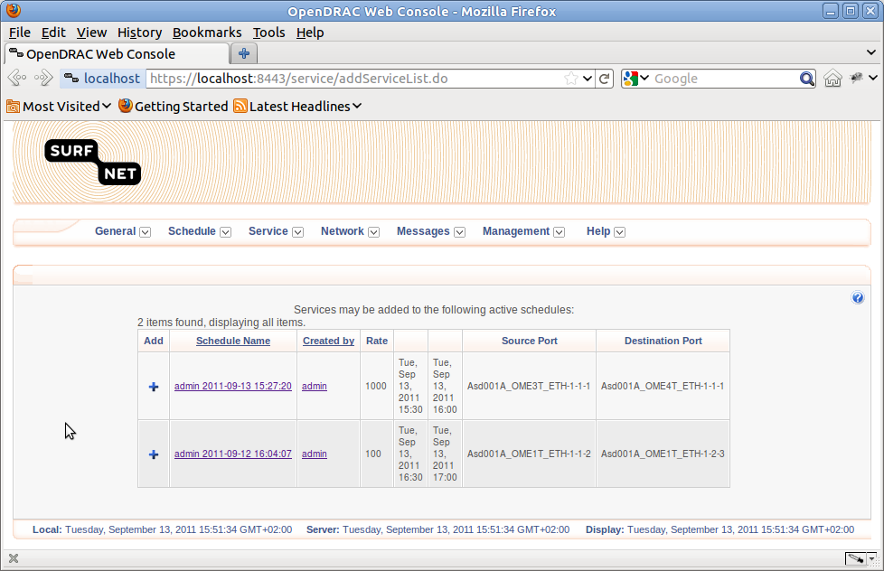

Figure 24: Schedules for adding a service

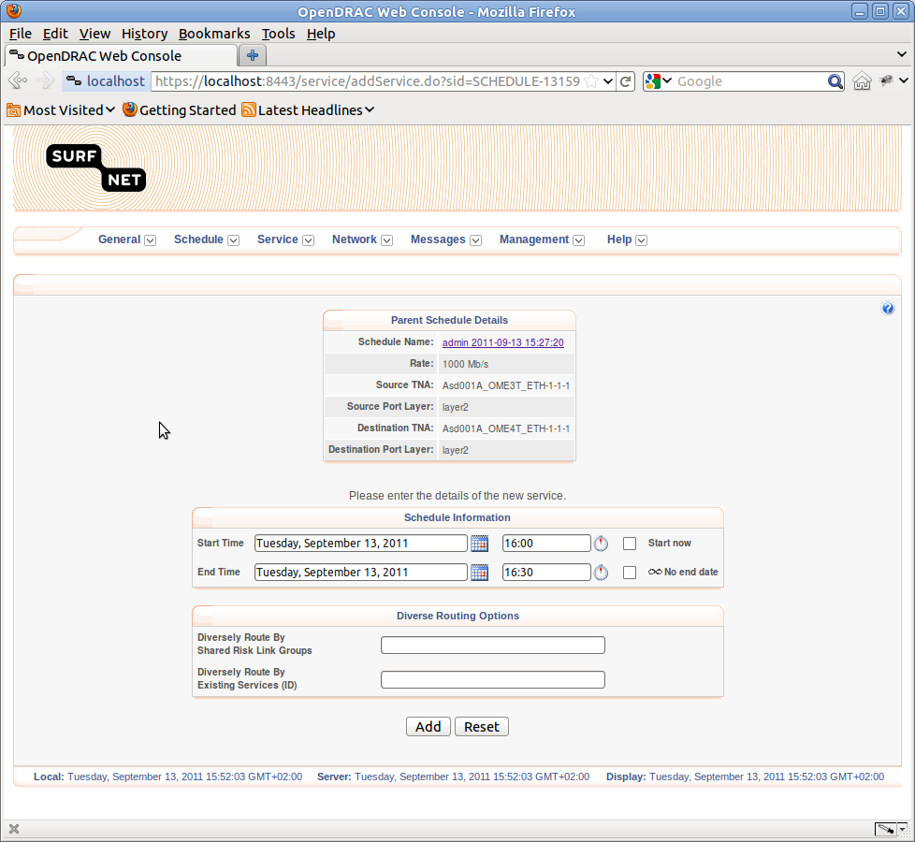

Figure 25: Form for adding a service

### Service Alarms

From the menu item Service → Service Alarms, the user can retrieve a list of service alarms. By setting the member group, start- and end time, the list can be filtered.

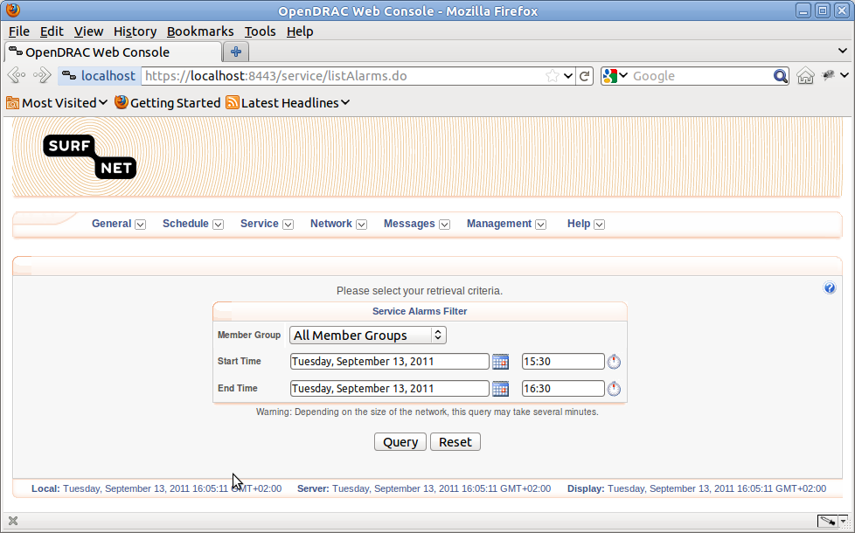

Figure 26: Form for retrieving alarms

## Menu Network

In menu item “Network” offers overviews of more general network related data. The following paragraphs describe the network related features of the web client.

### List Endpoints

From the menu item Network → List Endpoints, the user can retrieve an overview of endpoints. This list can be filtered by user group and endpoint layer.

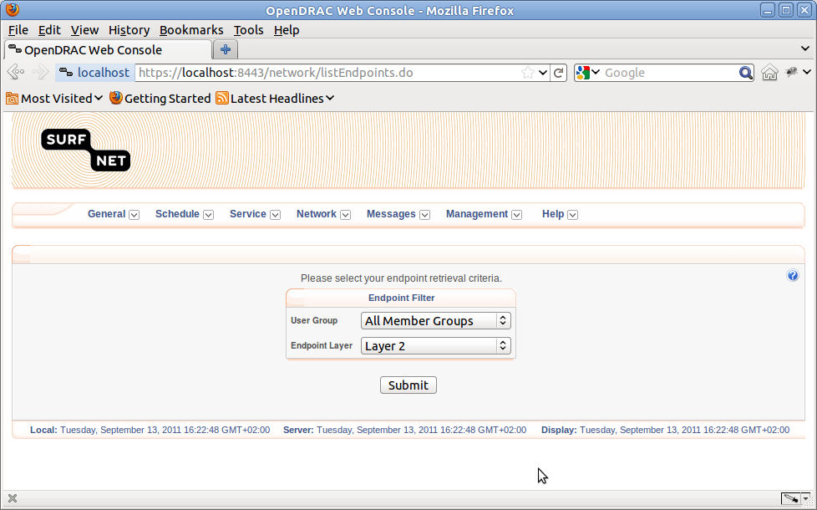

Figure 27: Form for retrieving list of endpoints

After setting the desired filter options and hitting the submit button, the client shows a table with endpoints. These endpoints are the termination points in the network elements connected to the server.

The table shows the following columns:

1. Entry: Serial number.
2. Details: By clicking on the plus-icon in the details column a row with detailed information about the service folds out. By clicking on the minus icon this row folds in again.
3. TNA identifier: the physical name of the termination point.
4. User Label: The logical name of the termination point.
5. Type: protocol of the port.
6. Port type: three port types are available:
7. UNI: User Network Interface: Port available to end user.
8. INNI: Internal Network to Network Interface: Intra network ports. These ports are used for links between NE's. These ports are not available to end users.
9. ENNI: External Network to Network Interface: Extra network ports. These ports are used for links between networks. These ports are not available to end users.
10. State: Status of the endpoint: IS = In Service, OOS = Out Of Service.
11. Data Rate: The data capacity of the end point.
12. MTU: Maximum Transmission Unit
13. VCAT: contiguous concatenation vs. virtual concatenation.
14. Utilization: This contains a bar describing the current utilization of the bandwidth offered by that termination point.
15. User Group: The user group responsible for the endpoint.

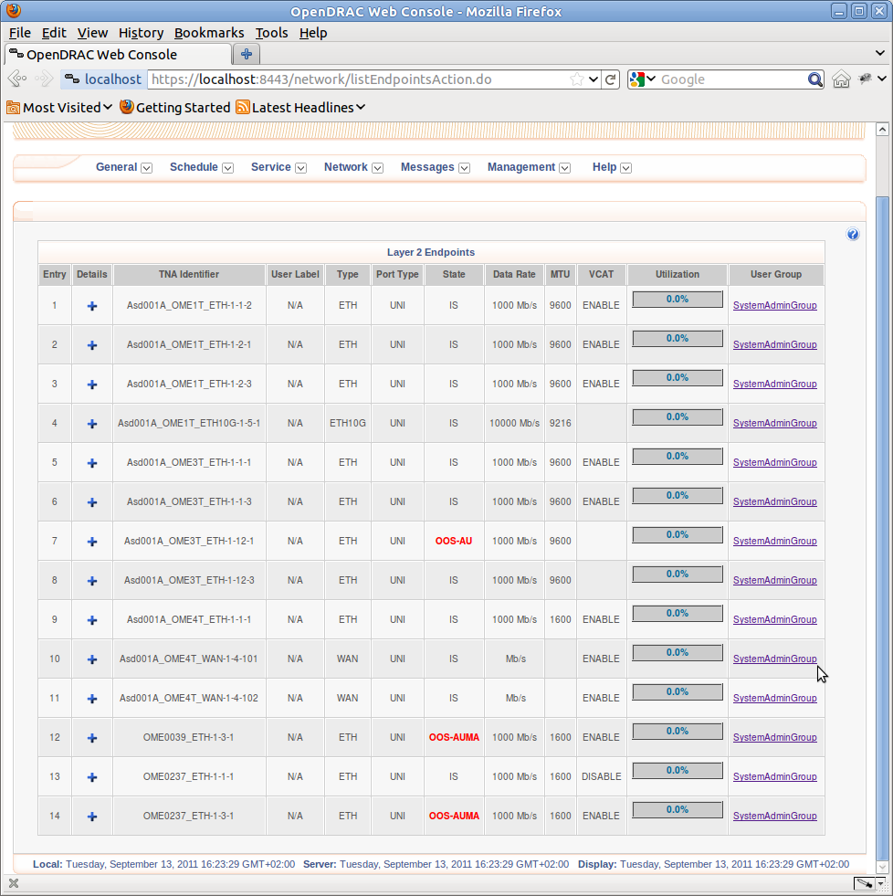

Figure 28: Retrieved list of endpoints

### Endpoint Utilization

From the menu item Network → Endpoint Utilization, the user can retrieve an overview of the utilization for a given end point in a given period. This period is defined by a start date and a date range. The options for the date range are day, week, month, or quarter year.

After setting these options and hitting the button “Query” a table and graphical data are displayed.

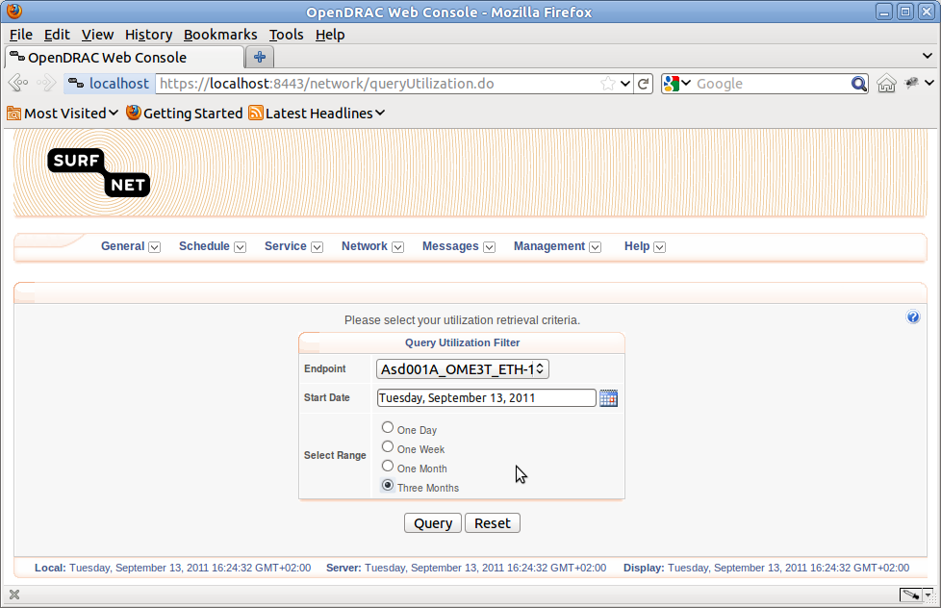The table shows the schedules and services utilizing the end point together with the bit rate, and start and stop time of the service. The last column of the table shows the current state of the service.

Figure 29: Form for retrieving endpoint overview utilisation

The graph displays the utilization percentage of the termination point as a function of the time.

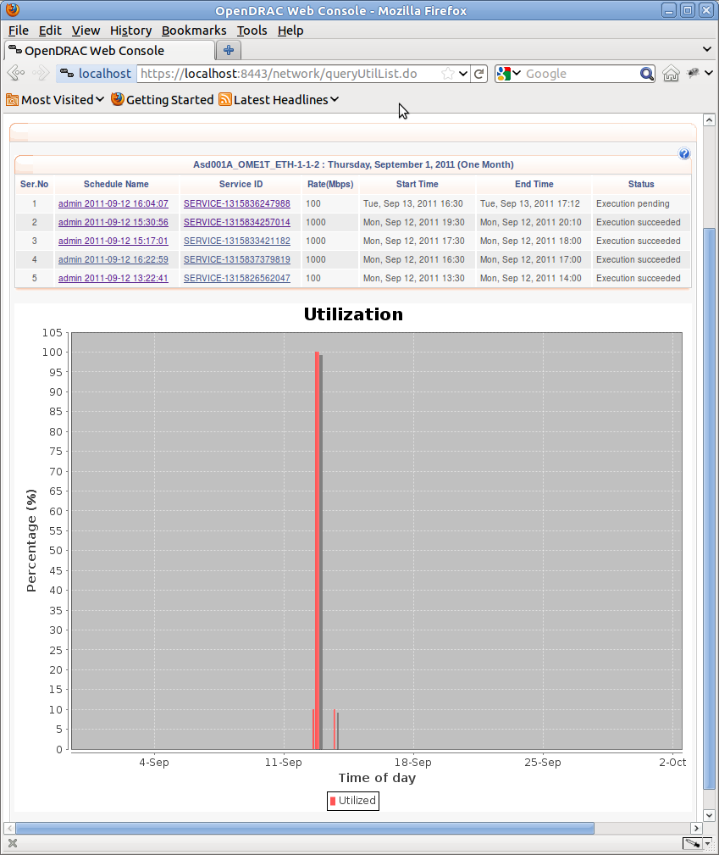

Figure 30: Overview endpoint utilisation

## Menu Messages

From the web client it is possible to “send“ messages to other registered users. The following paragraphs describe the components supporting this functionality.

### Compose New Message

From the menu item Messages → Compose New Message, the user can compose a message to send to another registered user. This works just like sending an ordinary e-mail message, except that no e-mail is sent. The messages are stored in the server and are only available in the web client.

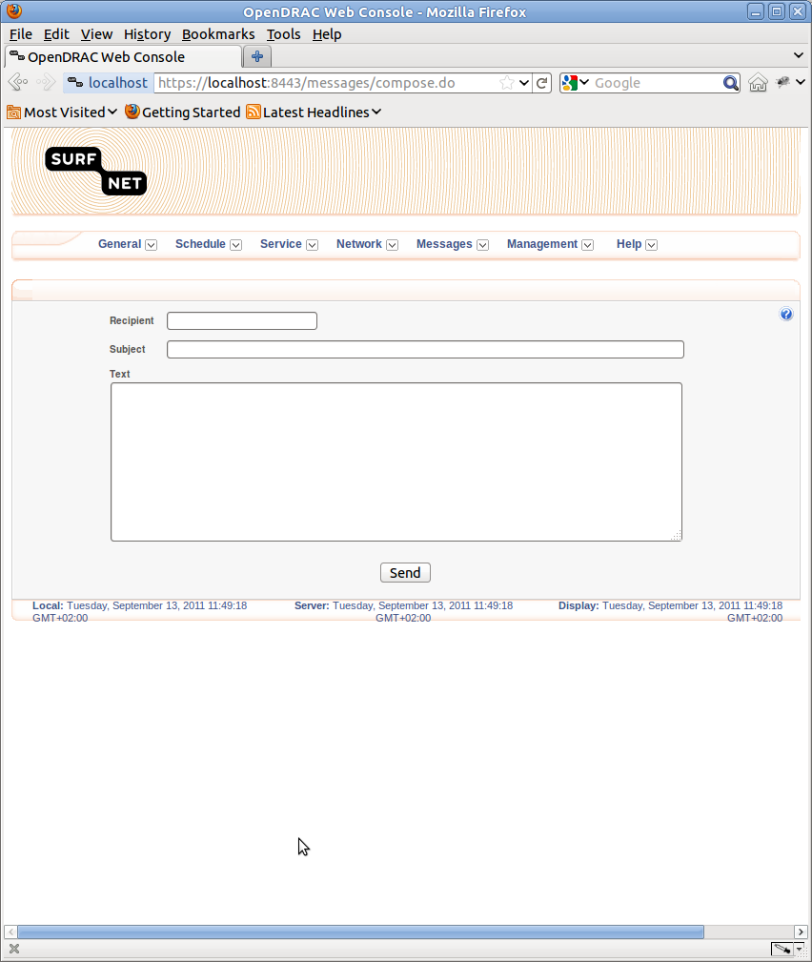

Figure 31: Compose message

### View Inbox

From the menu item Messages → Compose New Message, the user gets an overview of all received messages. These messages are displayed in a table.

Below the table three buttons are displayed:

1. Mark as Read: Marks all checked messages as read. After clicking on this button the icon in the second column has changed to a closed envelope.
2. Mark as Unread: Marks all checked messages as unread. After clicking on this button the icon in the second column has changed to an open envelope.
3. Delete: remove the message from the table.

By clicking on the icon in the second column you can force the table to refresh.

By clicking on the subject title of the message you are led to a screen with the message details. From this screen you can send a reply or delete the message.

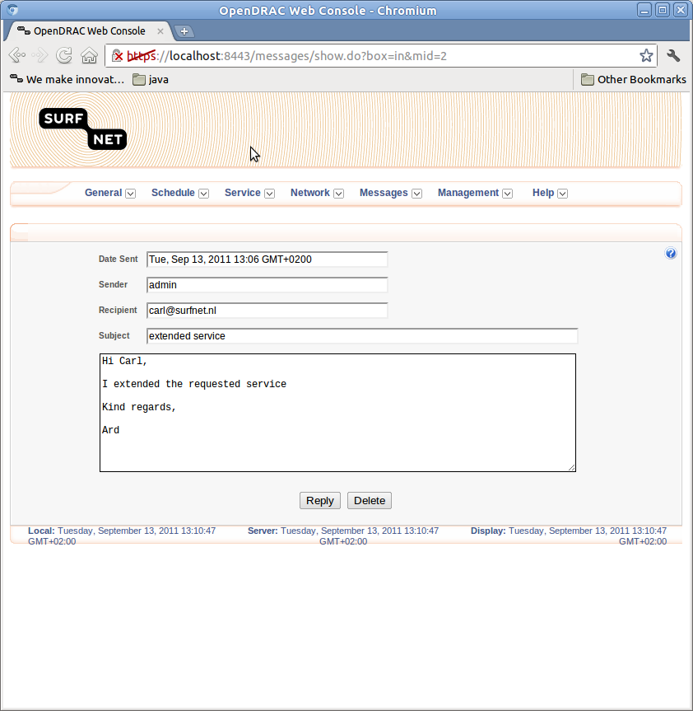

Figure 32: Details received message

### View Outbox

From the menu item Messages → View Outbox, the user gets an overview of all sent messages. These messages are displayed in a table. You can delete messages from this table by checking the messages to delete and then click on the button “Delete”.

If you click on the subject title of a message you are led to a screen with detailed information of the message. From this screen you can resend (an edited version) of the message. By clicking on the button “Delete” you delete the message.

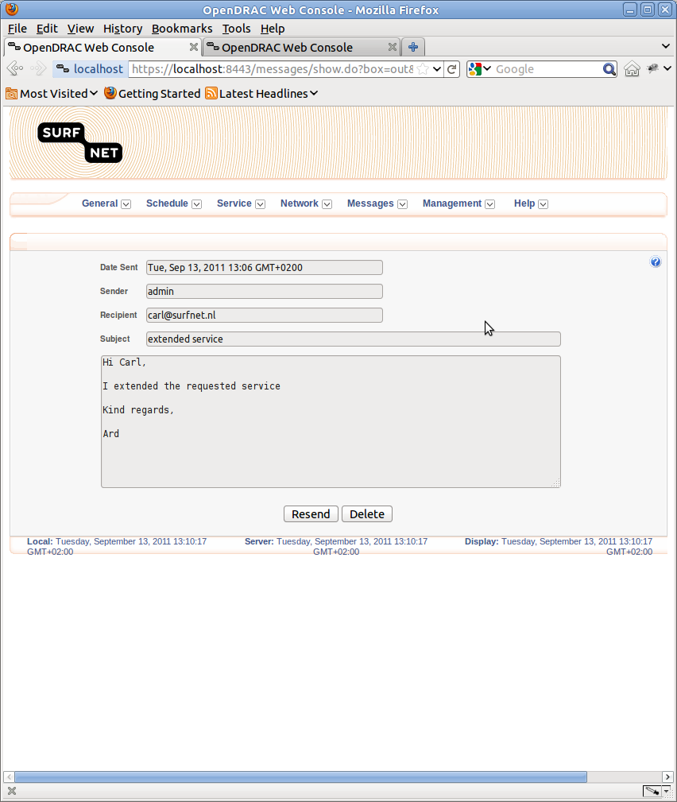

Figure 33: Details sent message

## Menu Management

OpenDRAC delivers an elaborate hierarchy consisting of users, user groups and resource groups. With this hierarchy you can control the conditions for access to resources. A resource is typically a termination point.

The hierarchy is as follows:

* Users are member of zero or more user groups.
* A user group has access to the resources in zero or more resource groups.
* A resource group contains zero or more resources.

Apart from the hierarchical structure it is possible to further define the conditions for access to resources. The following paragraphs give a detailed explanation of how to set up the access rules.

### List/Edit Users

From the menu item Management → List/Edit Users, the user gets an overview of all users in the OpenDRAC. You can find users by a variety of criteria. Currently the following search criteria are offered:

* All Users: Unfiltered
* Common Name: First name of the user.
* Description: Job description of the user.
* Email Address: Email address of the user.
* Given Name: First name of the user
* Phone Number
* Postal Address
* Surname: Last name of the user.
* Unassigned Users: Users not in any group.
* User ID

For all options but “All Users” and “Unassigned Users” you can search by text. In this text you can use wild cards.

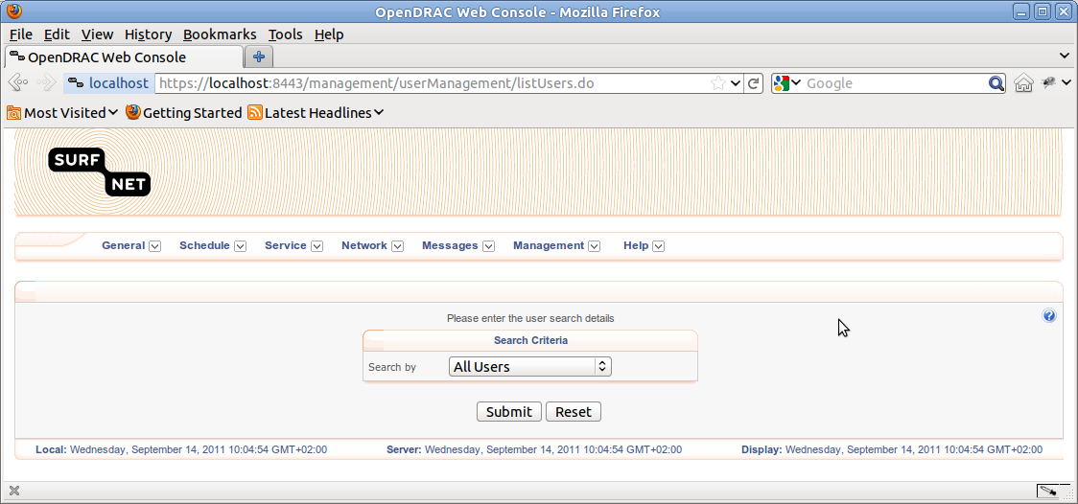

Figure 34: Form set to retrieve all users

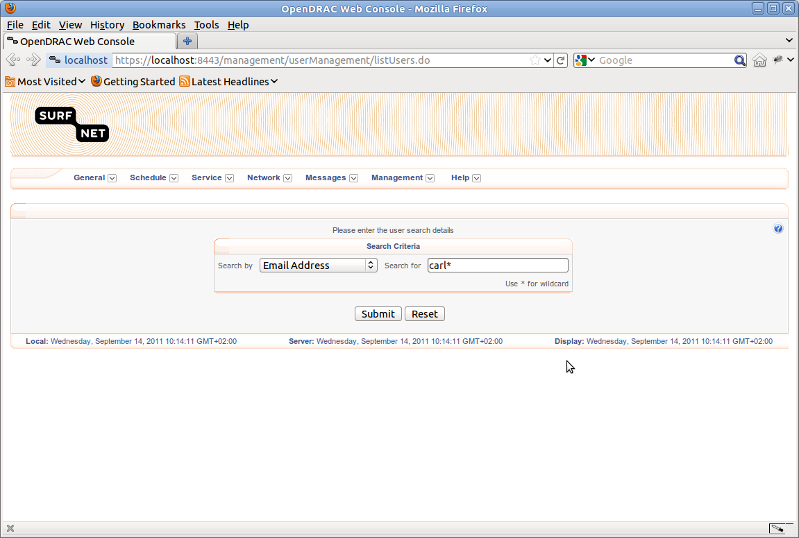

Figure 35: Form set to retrieve list of users matching expression for email address

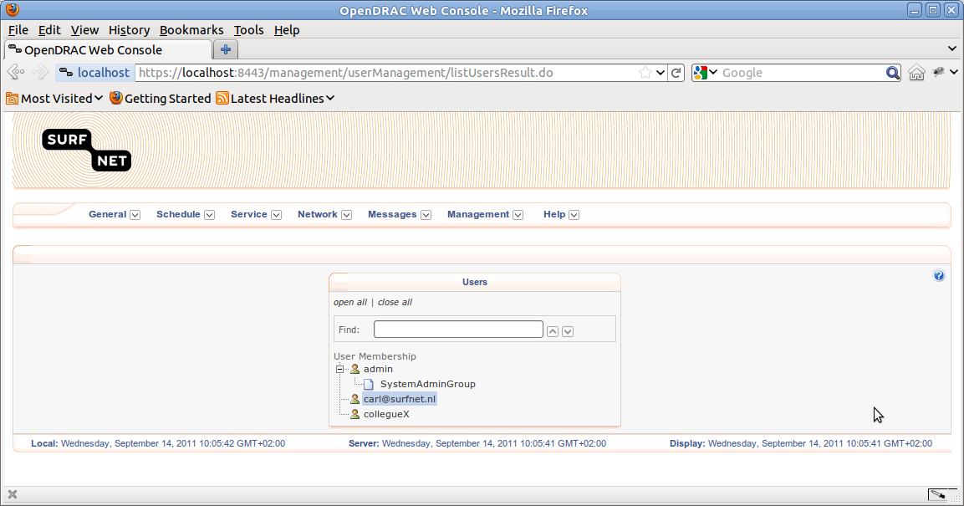

Figure 36: Overview with retrieved users

The resulting screen shows a tree with users and the user groups they are a member of. The text field at the top of this tree can be used to lookup a user in the current tree. By clicking on the name of a user or a user group you are redirected to a screen for editing this user or group.

### Create User

From the menu item Management → Create User, you can create a new user. To do so, you'll have to fill in a large form that consists of 6 tabs.

#### User

The tab “User” consists of the following fields:

1. User ID: name used for logging in.
2. Account State: enabled vs. disabled.
3. WS Password: here you enter your own password.
4. Authentication Type:

* Internal: use the internal authentication of OpenDRAC.
* A-select: the open source authentication system for users in a Web environment.

1. User Password: the password you assign to the user.
2. Confirm User Password: the password you assign to the user again, to make sure you did not enter a typo the first time.

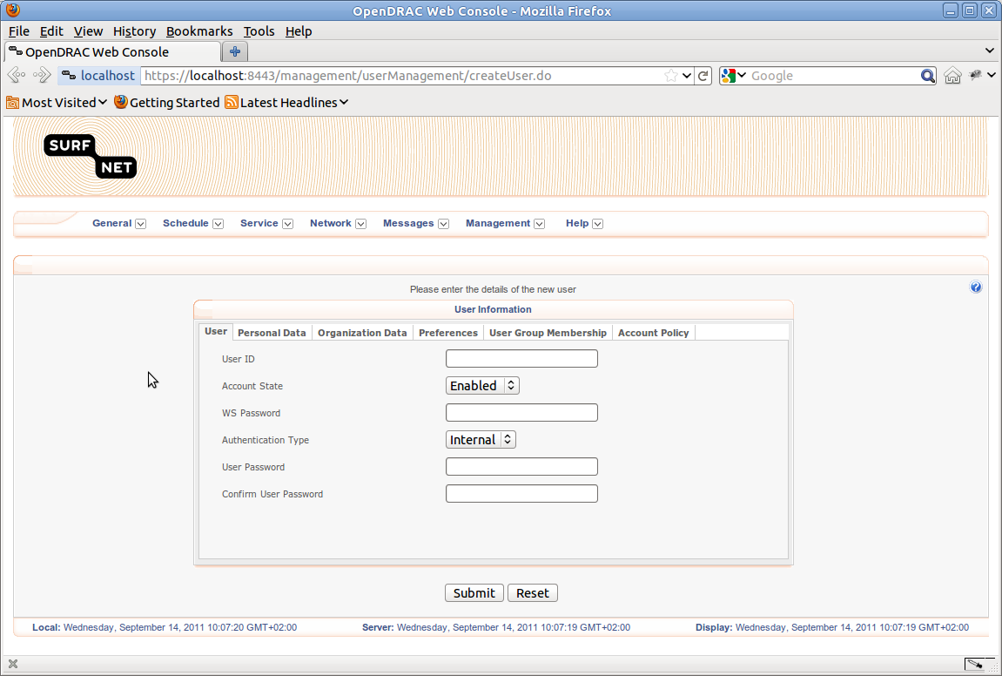

Figure 37: Form to create a new user, User tab

#### Personal Data

* The tab “Personal Data” consists of the following fields:
* Surname: Last name of the user.
* Email: Email address of the user.
* Given Name: First name of the user
* Telephone : Telephone number of the user.
* Common Name: First name the user is generally address with.
* Postal Address: Address to send paper mail to.
* Title: Academic title.
* Description: Job description.

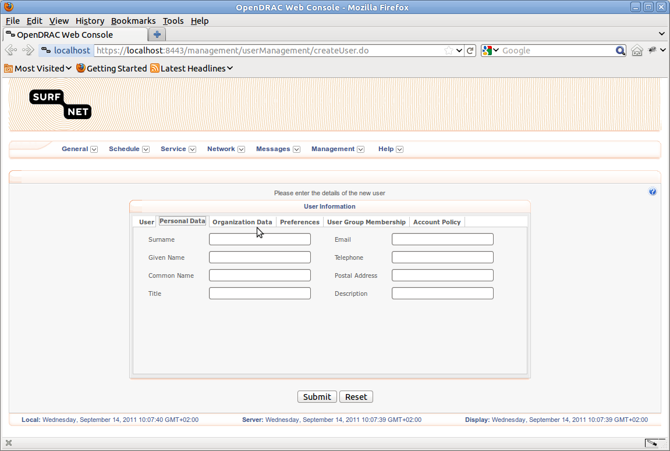

Figure 38: Form to create a new user, Personal Data tab

#### Organization Data

* The tab “Organization Data” consists of the following fields:
* Organization Name: Employer of the user.
* Unit Name: Department or unit of the organization.
* Owner: Owning company/organisation of the organisation.
* Description: Short company description.
* See Also: Reference to an extended company description.
* Category: Type of the company.

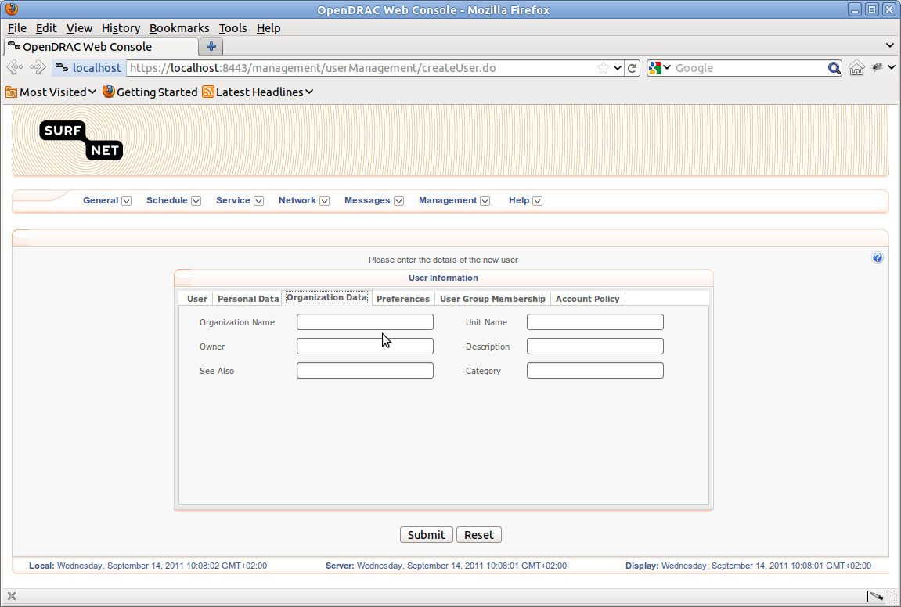

Figure 39: Form to create a new user, Organization Data tab

#### Preferences

In the tab “Preferences” you can set the time zone of the user.

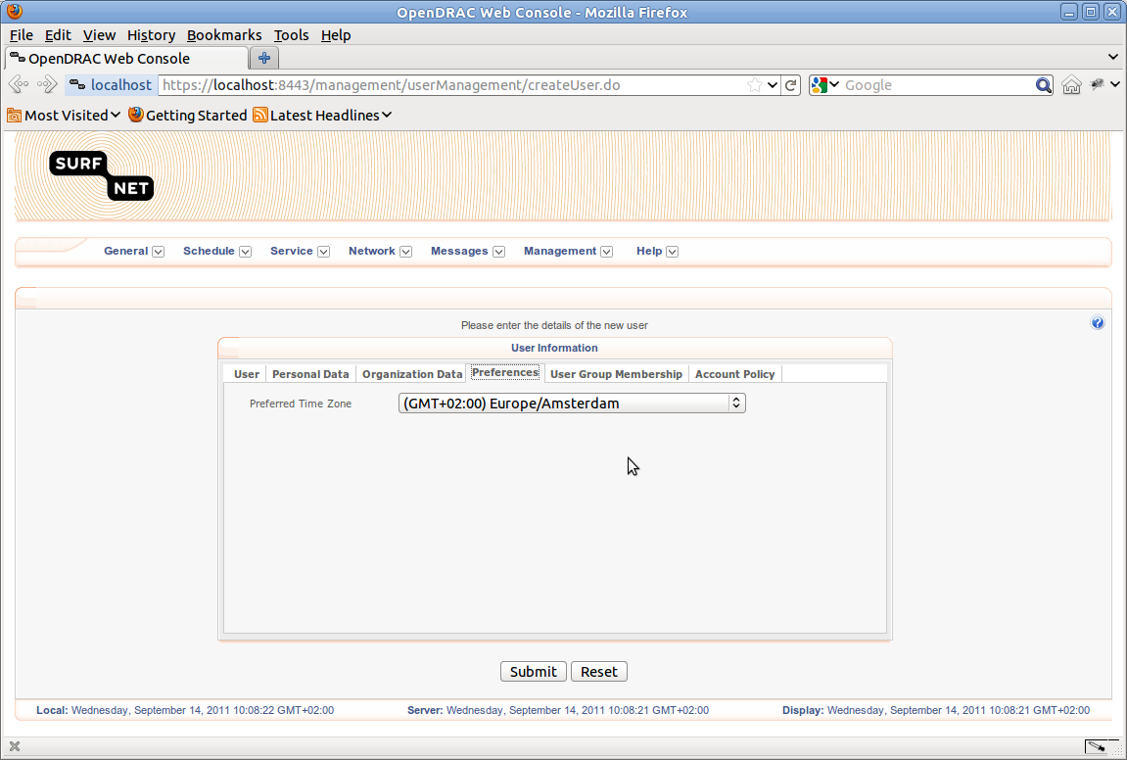

Figure 40: Form to create a new user, Preferences tab

#### User Group Membership

In the tab “User Group Membership” you can set user groups this user is a member of.

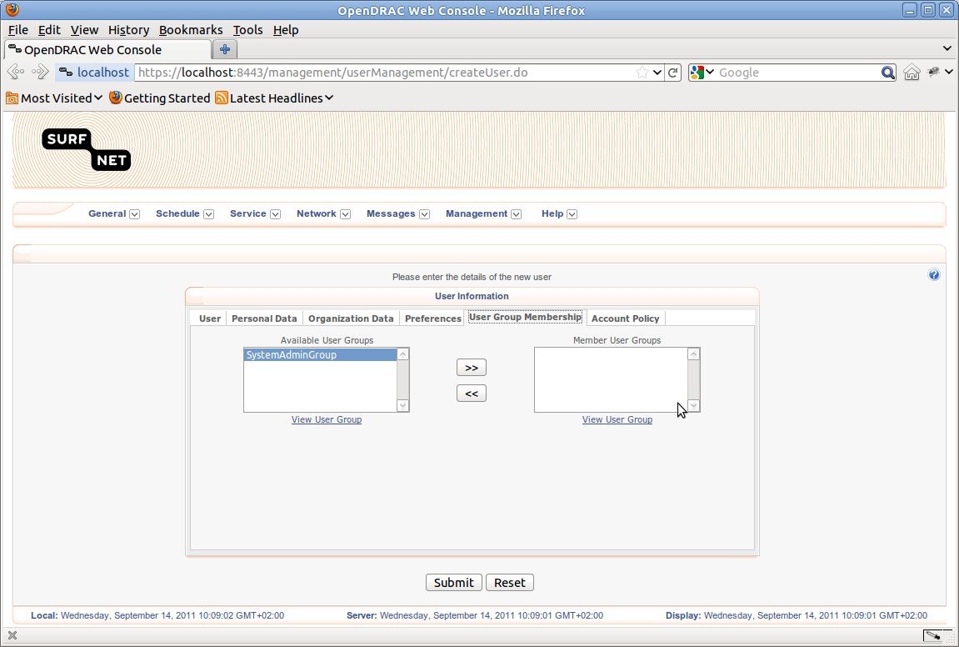

Figure 41: Form to create a new user, User group Membership tab

#### Account Policy

The tab “Account Policy” consists of the following fields:

* Dormant Period : The period of time after which, if there has been no attempt to login to the system, the system will automatically disable a user's account. A value of "0" indicates this check is disabled.
* Inactivity Period: The period of the time a user accessing the system through a GUI can be inactive after which their session will be automatically terminated. A value of "0" indicates this check is disabled. This period can be specified in seconds, minutes, hours or days.
* Password History Size: The number of old passwords to maintain in a user's password history.
* Maximum Login Attempts: The maximum number of invalid login attempts permitted per user before the account lockout period is invoked. A value of "0" indicates this check is disabled.
* Lockout Period: The duration a user account will be disabled following multiple login failures (determined by Maximum Login Attempts). This period can be specified in seconds, minutes, hours or days.
* Password Aging: The maximum age in days of a user password, i.e. the time duration between forced password changes. A value of "0" indicates this check is disabled.
* Password Expiration Notification: The number of days before a user's password expires that the system will start to notify the user to change their password.
* Lock This Client IP Address Permanently: An IP address that is to be blocked from accessing the system.
* Permanently Locked IP Addresses: The list of IP addresses currently blocked from accessing the system.

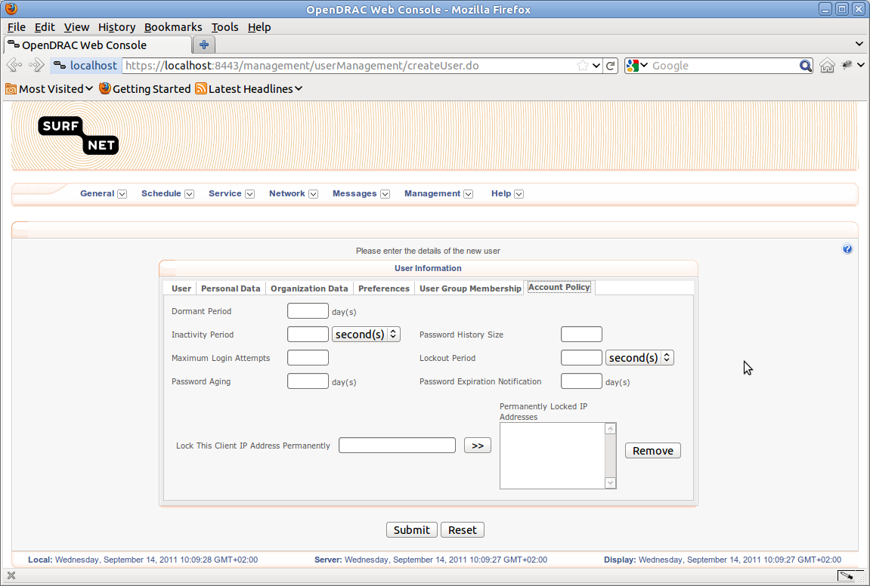

Figure 42: Form to create a new user, Account Policy tab

### List/Edit User groups

From the menu item Management → List/Edit User Groups, the user gets an overview of all user groups in OpenDRAC. The results are presented in a tree structure. If the list of user groups is extensive, you can search by group name.

By clicking on an item in the tree, you are redirected to a screen to edit that item.

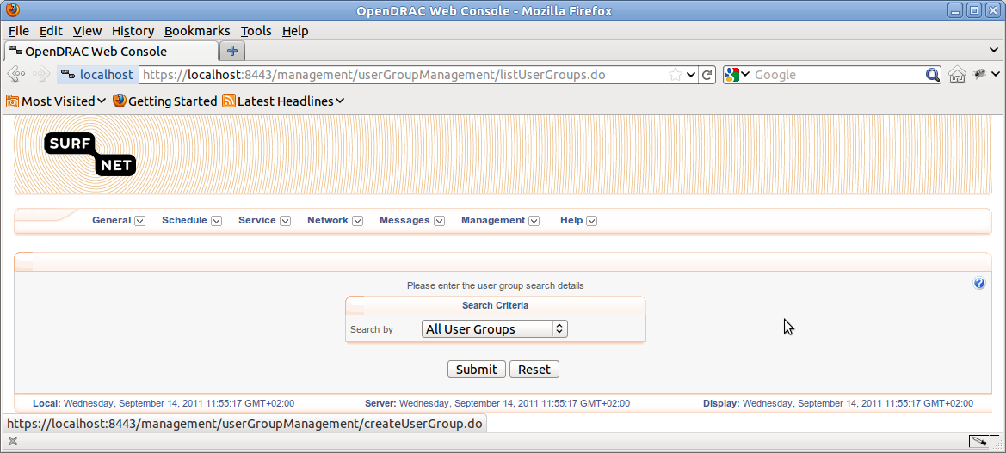

Figure 43: Form set to retrieve all user groups

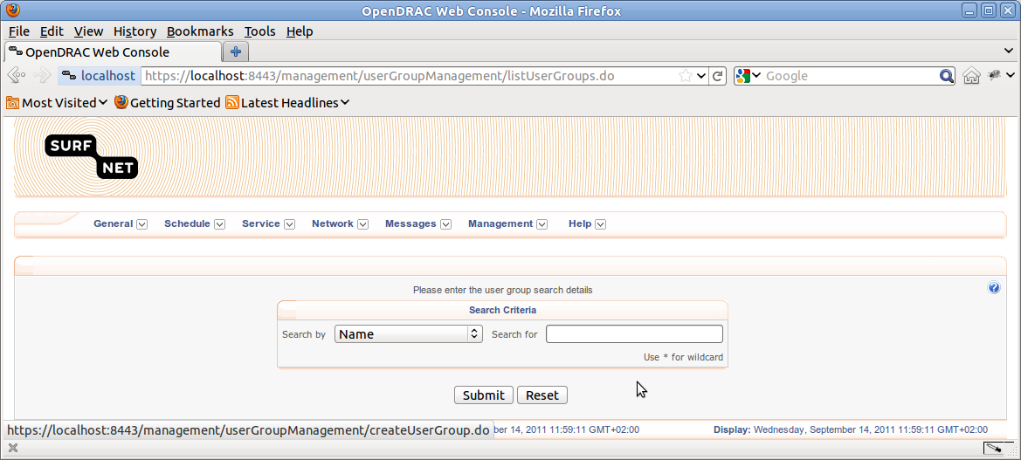

Figure 44: Form set to retrieve users by expression for group name

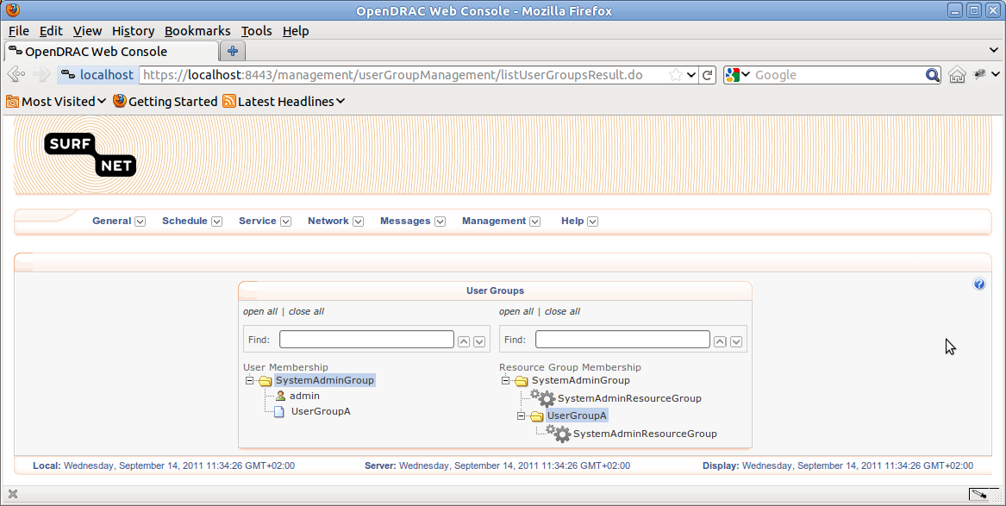

Figure 45: Overview of user groups

### Create User Group

From the menu item Management → Create User Group, you can create a new user group. To do so, you'll have to fill in a large form that consists of a pane in the top and 4 tabs.

#### Top pane

In the top pane of the screen for creating a user three fields are presented:

* Name: Name of the user group.
* User Group Type: The type of the user group. Three options are available:
* *User:* Offers access to basic user capabilities through the system.
* *System Administrator:* Offers access to all capabilities through the system.
* *Group Administrator:* Offers access to basic user and group administrator capabilities through the system.
* Parent User Group: The parent user group of the currently being defined group. This list is dynamic and is restricted to those user groups that are permitted as parents for the currently logged in user.

The user is stored in the server after clicking on the button “Submit”. This will store the data of all four tabs.

#### Users Tab

Under the tab “Users” you define the users that are a member of the user group. You can add and remove users by moving them from the list in the left block to the right block and vice versa.

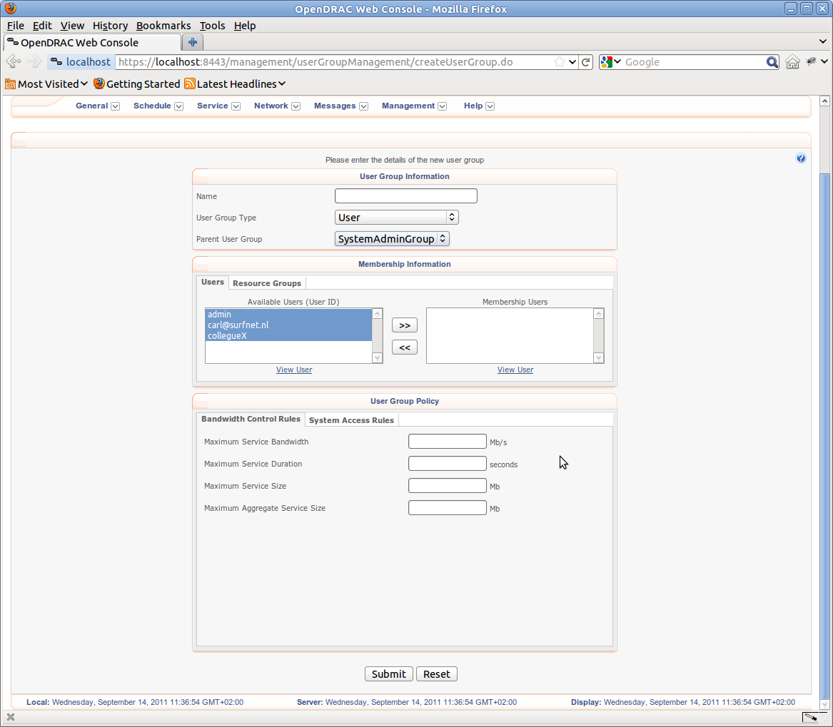

Figure 46: Form for creating a new user group with tab Users active

#### Resource Groups Tab

Under the tab “Resource Groups” you define the resource groups that are available to the user group. A resource group consists of a series of termination points. You can add and remove resource groups by moving them from the list in the left block to the right block and vice versa.

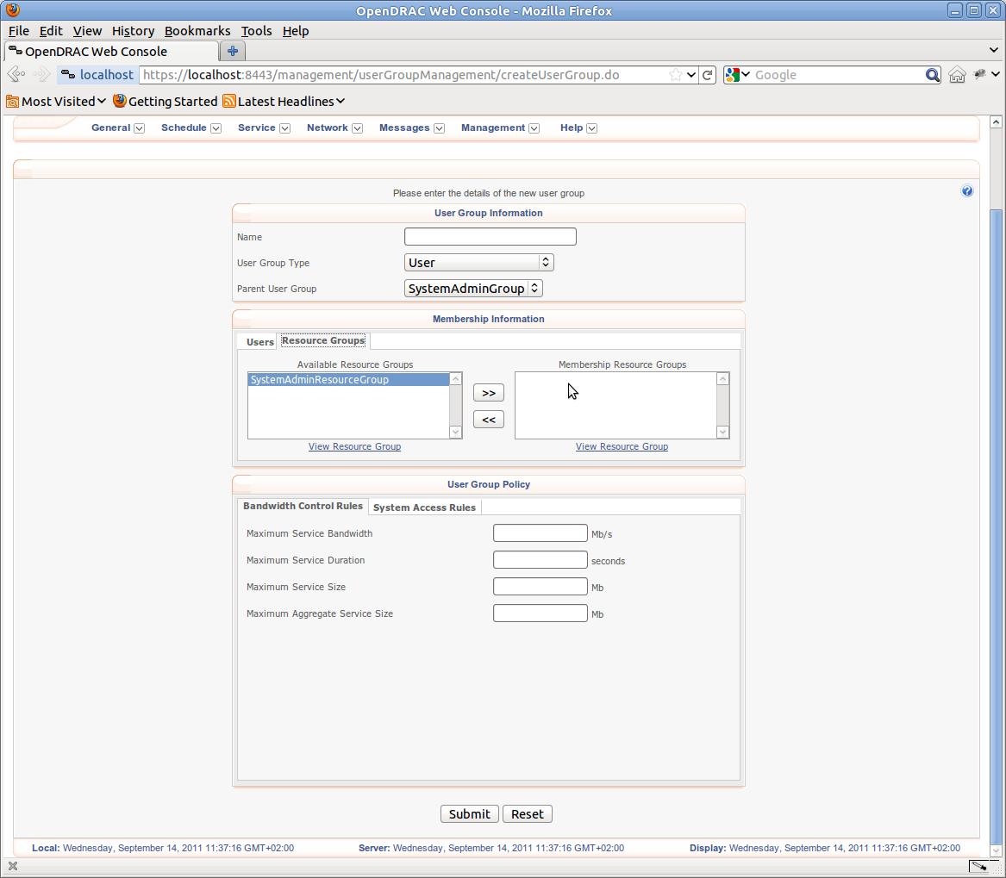

Figure 47: Form for creating a new user group with tab Resource Groups active

#### Bandwidth Control Tab

In the tab Bandwidth Control the following fields are available:

* Maximum Service Bandwidth: The maximum bandwidth (service size * service duration) (in Mbits) that can be requested for a single service. Absence of a rule represents no restriction on bandwidth.
* Maximum Service Duration: The maximum service duration (in seconds) that can be requested for a single service. Absence of a rule represents no restriction on duration.
* Maximum Service Size: The maximum service size (in Mbits/second) that can be requested for a single service. Absence of a rule represents no restriction on service size.
* Maximum Aggregate Service Size: The maximum aggregate service size allowed (in Mbits). Limits the total instantaneous bandwidth allowed within the network on a per-user group basis when specified against a user group.



Figure 48: Form for creating a new user group with tab Resource Groups active

#### System Access Rules Tab

In the tab “System Access Rules” you can add multiple rules that define periods the user has, or has not got access to the system.

Two types of rules are available:

* grant: define that the user does have access in the registered period.
* deny: define that the user has no access in the registered period.

The other fields are for defining the period.

Once you've defined a rule you hit the button “Add rule”, and the new rule is added to the list below the form. To delete a rule click on the red icon. The rule are stored in the server after clicking on the button “Submit”.

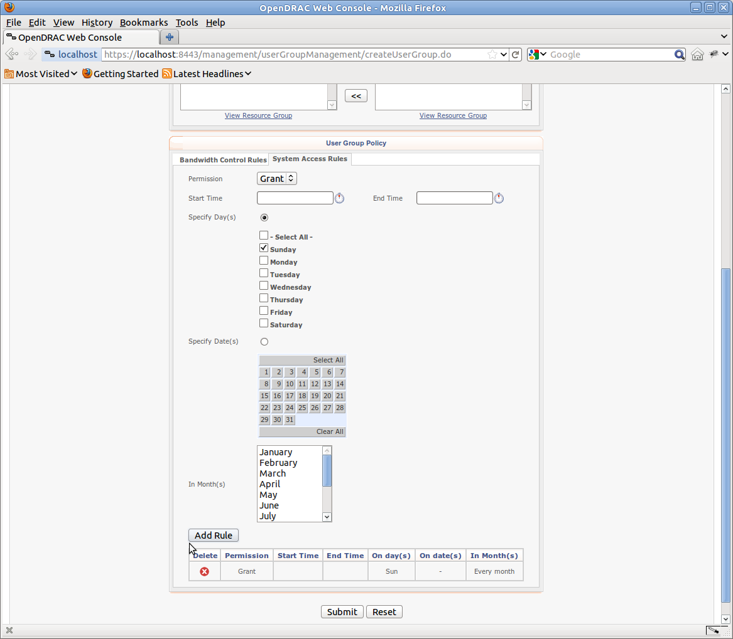

Figure 49: System access rules for user group

### List/Edit Resource groups

From the menu item Management → List/Edit Resource Groups, the user gets an overview of all resource groups in the OpenDRAC. The results are presented in a tree structure. If the list of groups is extensive, you can search by group name. By clicking on an item in the tree, you are redirected to a screen to edit that item.

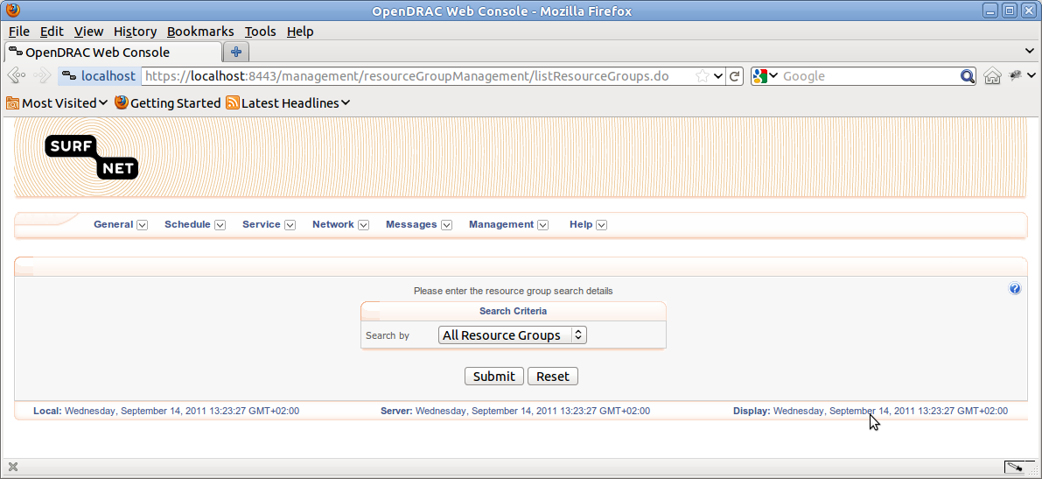

Figure 50: Form set to retrieve all resource groups



Figure 51: Form set to retrieve resource groups by expression for group name

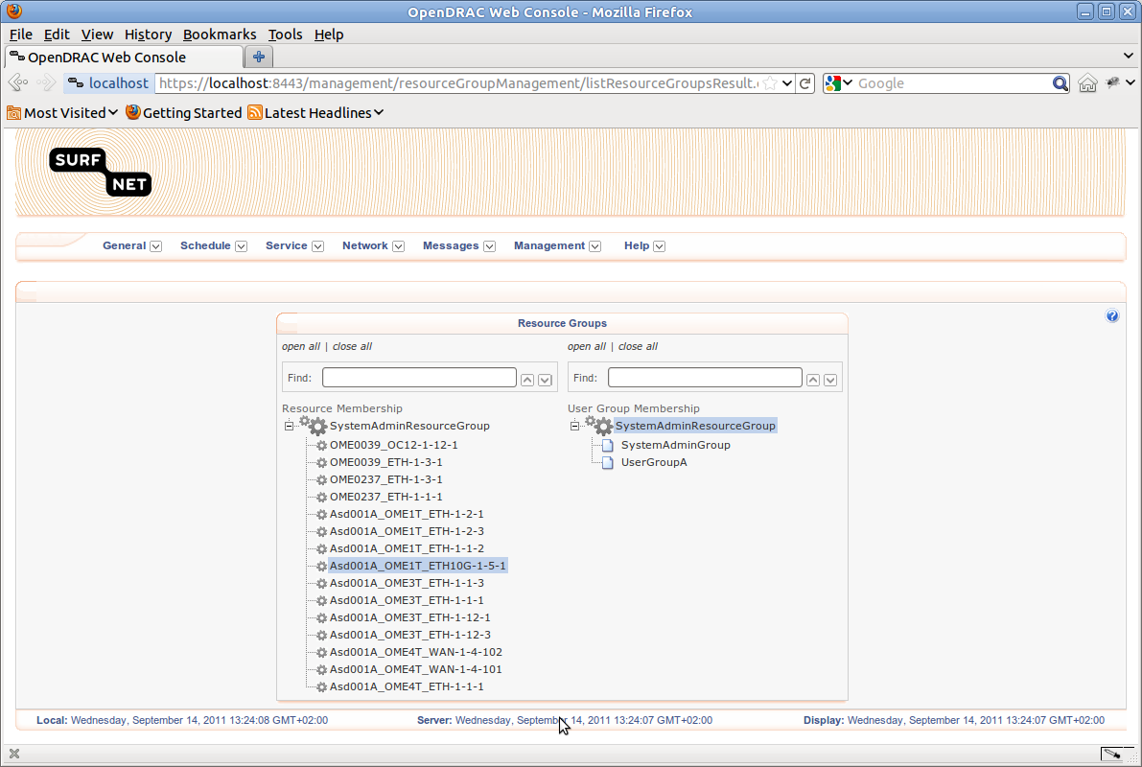

Figure 52: Overview of retrieved resource groups

### Create Resource Group

From the menu item Management → Create Resource Group, you can create a new resource group. To do so, you'll have to fill in a large form that consists of a top pane and two tabs.

In the top of the screen for creating a resource group two fields are presented:

1. Name: The name of the resource group
2. Parent Resource Group: resource groups are organized in an hierarchy. In this field you define the parent group. This is either the default top level group, or a user defined group that is an ancestor to the top level group

The two tabs are:

1. Resources: By selecting resources and moving these from the left to the right overview you add resources to the group. Users that have this group assigned will have accesses to the resources in the resource group. OpenDRAC has one special resource group: SystemAdminResourceGroup. This is the mother of all resource groups and gives access to all resources. For this group is stated in the top of the form, that it is a default group. For this group it is not possible to manage resources. This group is created at installation of OpenDRAC.
2. User groups: By adding user groups to the resource groups, users in these user groups get access to the resources of the resource group. Adding user groups is done , similar to adding resources, by selecting users and moving them from the listing in the left to the one in the right.

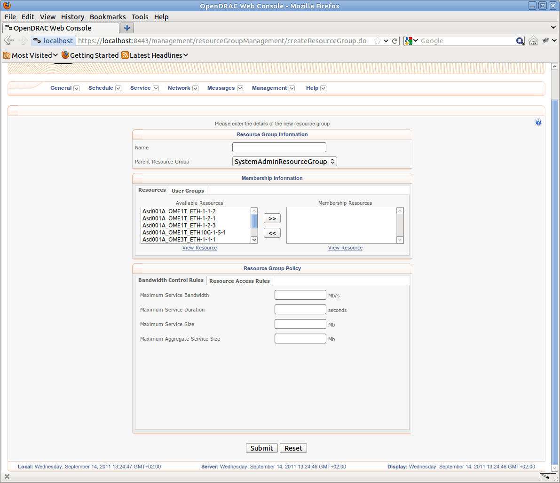

Figure 53: Create resource group, tab Resources active

#### Bandwidth Control Rules Tab

In the tab Bandwidth Control Rules the following fields are available:

* Maximum Service Bandwidth : The maximum bandwidth (service size * service duration) (in Mbits) that can be requested for a single service. An absent rule represents no restriction on bandwidth.
* Maximum Service Duration : The maximum service duration (in seconds) that can be requested for a single service. An absent rule represents no restriction on duration.
* Maximum Service Size : The maximum service size (in Mbits/second) that can be requested for a single service. An absent rule represents no restriction on service size.
* Maximum Aggregate Service Size: The maximum aggregate service size allowed (in Mbits). Limits the total instantaneous bandwidth allowed within the network on a per-user group basis when specified against a user group.

#### System Access Rules Tab

In the tab “System Access Rules” you can add multiple rules that define periods the resource group is available for services.

Two types of rules are available:

1. grant: define that the user does have access in the registered period.
2. deny: define that the user has no access in the registered period.

The other fields are for defining the period.

Once you've defined a rule and clicking on the button “Add rule”, the new rule is added to the list below the form. To delete a rule click on the red icon. The rule is stored in the server after clicking on the button “Submit”.

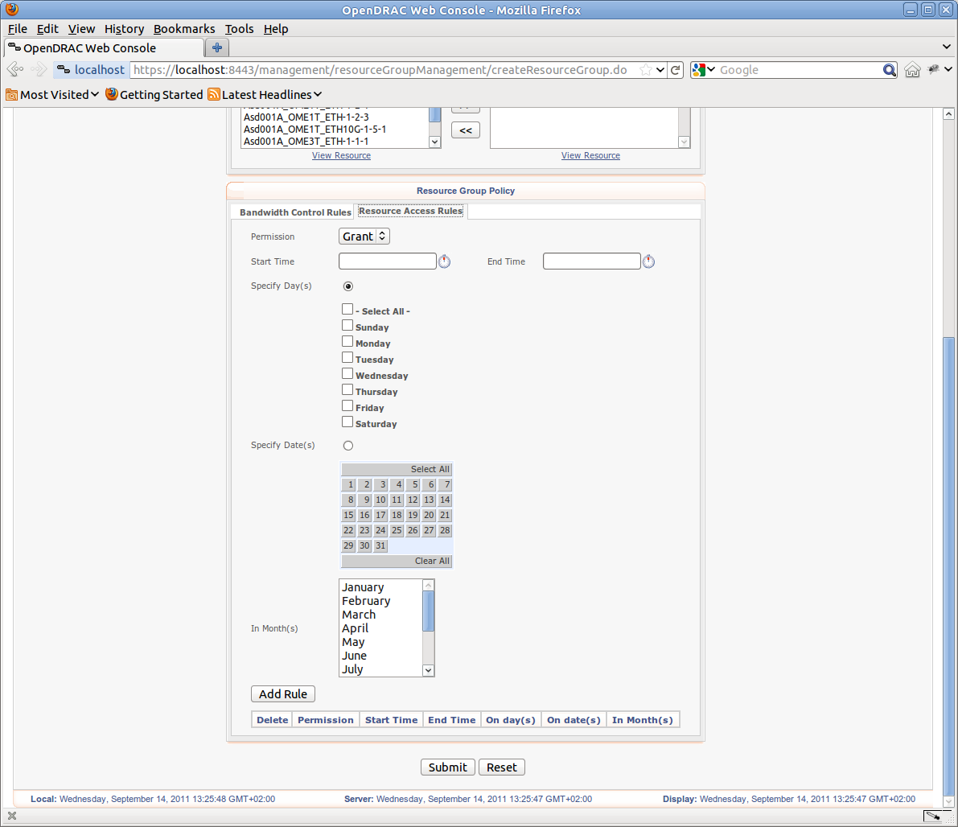

Figure 54: Create resource group, tab Resource Access Rules active

### Global Security Settings

From the menu item Management → Global Security Settings, you can define security settings that apply globally to all users and/or user groups and/or resource groups. Information is presented via four tabs that group related information.

#### Tab Authentication

In the tab “Authentication” you can set the available authentication types and the dormancy period.

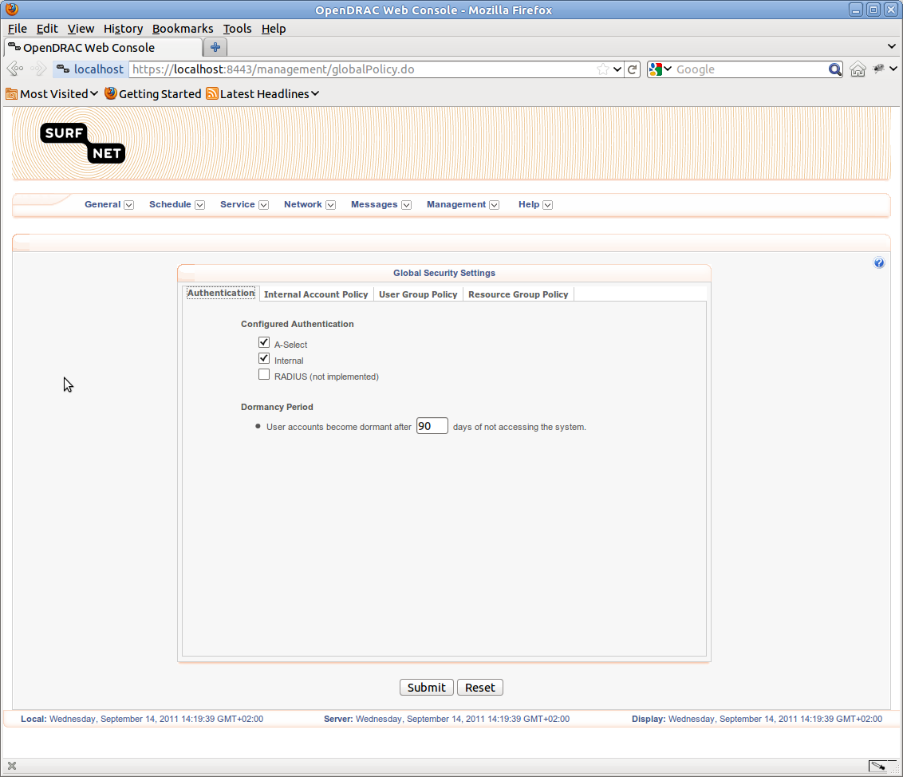Tab Internal Account Policy

Figure 55: Change Authentication data for global security settings

The tab “Internal Account Policy” defines the policy to be applied globally to internal accounts. This tab has two inner tabs:

Account Policy

This tab has the following fields:

* Automatically log user out after period of inactivity: after what time of inactivity the user is logged out.
* Failed Logins: The maximum number of failed logins. If this amount is exceeded the account is locked for a configurable period of time. This is defined by the fields “Maximum allowed attempts” and “Lockout Period”
* Permanently Locked IP Addresses: Add or remove IP addresses that are excluded from access to the server.
* Temporarily Locked IP Addresses: IP addresses that are excluded from access to the server due to exceeding failed logins within a certain period of time. Settings are configured at the starting of the server. This GUI only provides functionality to remove the IP address from the list of locked addresses.

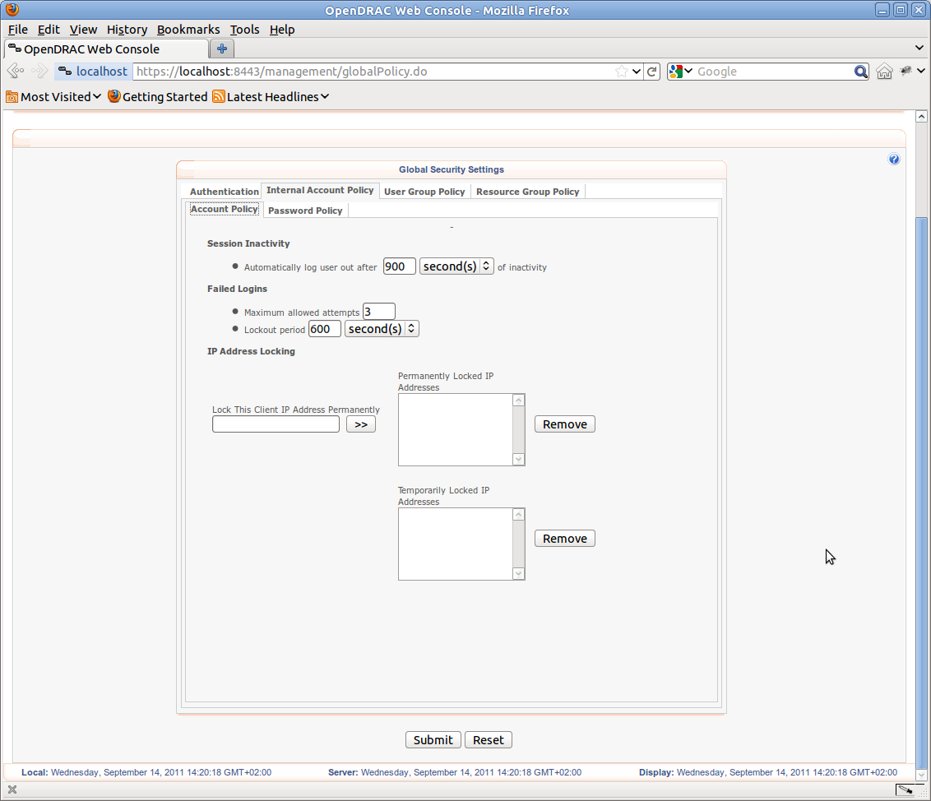Password Policy

Figure 56: Change internal account policy data for global security settings

This tab contains the following fields, that combined together define the rules a password must comply to.

* Passwords expire after: Self defining.
* Start to notify user: Self defining.
* Maintain n passwords in a user's password history: store a number of passwords to prevent from reusing a password at defining a new one.
* Minimum Password Length: Minimum number of characters in a password.
* Minimum Alpha Characters: minimum number of letters in a password.
* Minimum Numeric Characters: Minimum number of numerical digits in a password.
* Minimum Different Characters: Defines variety of characters within a password.
* Minimum Special Characters: Self defining.
* Permitted Special Characters: sums up all non-alpha-numeric characters that are allowed in a password as a single string. (space is considered a special character)

#### Tab User Group Policy

Figure 57 Change password policy data for global security settings

#### This tab is for setting global security settings for user groups. See for an explanation of this tab the explanation at the paragraph describing creating a new user group.

#### Tab Resource Group Policy

This tab is for setting global security settings for resource groups. See for an explanation of this tab the explanation at the paragraph describing creating a new resource group.

### Edit User Profile

From the menu item Management → Edit User Profile, you can change your profile. For an explanation read the paragraph that describes creating a new user.

### Change Password

From the menu item Management → Change password, you can change your password. Just fill in your current password and fill in the new password twice.

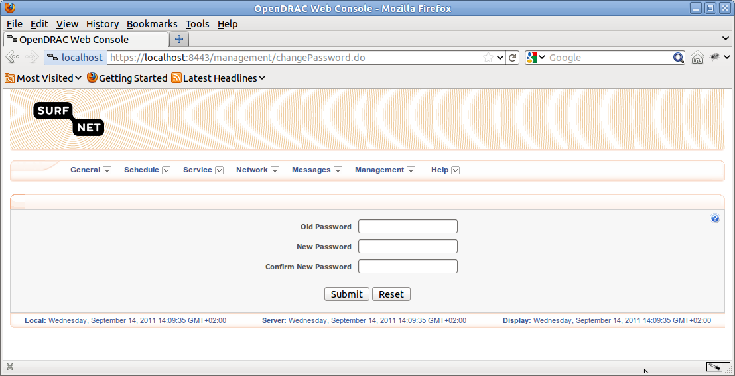

Figure 58: Form to change your password

## Menu Help

The help menu presents meta data of OpenDRAC itself. It offers static information in web pages and additional tooling as a file to download. The following paragraphs give a detailed description if this functionality.

### Downloads

From the menu item Help → Downloads, the user gets an overview of additional tooling he can download.

The following extra tooling is offered as a download:

1. Administration Console: A Java client for managing network elements. There is quite some overlap in functionality with the web client. How to use this client is described elsewhere in this document
2. Web services client 2.x.x: Client to control OpenDRAC via web services. This option is offered for customers that already use version 2 and only want bug fixes. New users should download version 3.
3. Web services client 3.x.x: Client to control OpenDRAC via web services, this is a further development of version 2.x.x. It contains more features than version 2.
4. Automation Tool: A command line tool for simple provisioning tasks. It runs on Linux Mac OS and windows. The zip contains a user manual.

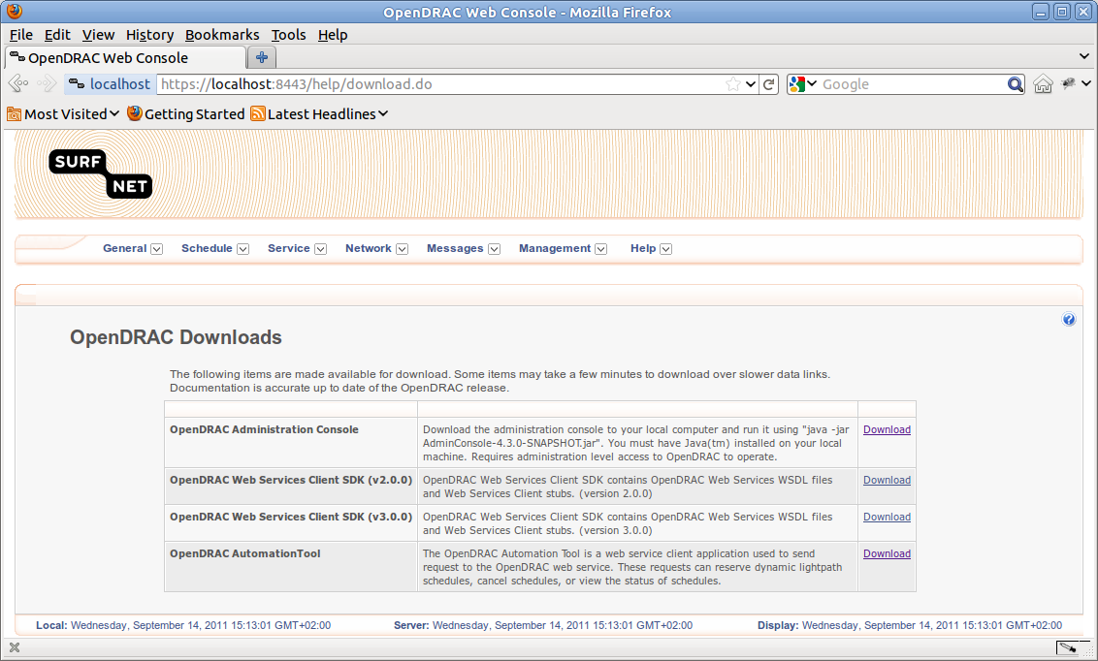

Figure 59: Downloads page

### Browser Compatibility

From the menu item Help → Browser Compatibility, the user gets an overview of supported browser for the web client of OpenDRAC.

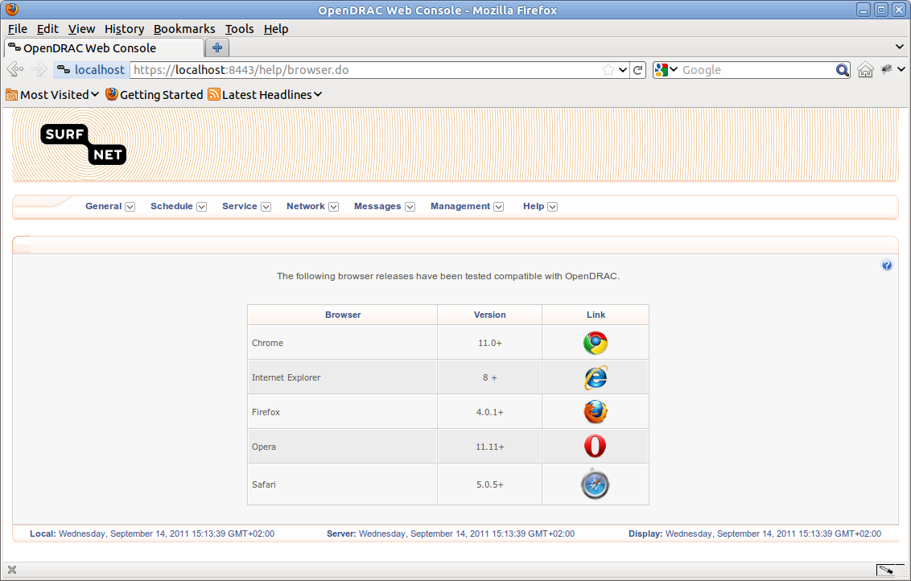

Figure 60: Browser compatibility overview

### About OpenDRAC

From the menu item Help → About OpenDRAC, the user gets an overview of the architecture of OpenDRAC.

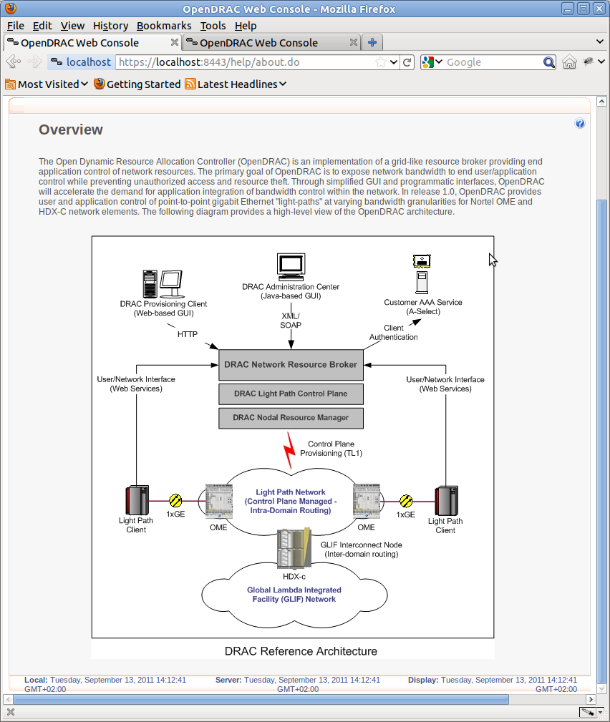

Figure 61: Open DRAC overview

# Use Cases

This chapter contains general explanations of “every day” use cases. The goal is raise a general understanding of the described features. For simplicity they only give a brief description. To fill in the details read the referenced paragraphs.

## Scheduling a service

As stated before, the primary goal of OpenDRAC is to enable users to temporarily reserve bandwidth on dedicated “lines” between two end points. A reservation is done by creating a schedule. Creating a schedule results in one or more services. I.e. a schedule can be viewed as a template for a service. A service is a light path between two end points for a defined period of time.

The web client offers two methods of creating a schedule :

1. Simple create schedule: (Schedule → Create Schedule) use this screen if you are sure the termination points are available for the requested period and if the settings other than the ones offered by this screen have the default value. The usage of this screen is described in paragraph 3.2.3 In most cases the first option is good enough. This screen contains far less input values than the screen of the second option.
2. Advanced create schedule: (Schedule → Create Schedule) use this screen if non default values are required, or if you do not already know if the resources will be available. The usage of this screen is described in paragraph 3.2.2

If you want to know if the resources for your schedule are available, you can query the schedules for the given period. This is described in paragraph 3.2.1.

Instead of verifying the availability of the resources for your schedule before creating it, you can also do this while creating it. This is done in the screen for the advanced creating a schedule. To use this at least the following items have to be filled in:

1. Start time
2. End time or service duration
3. Source end point
4. Target end point
5. Bit rate

After these items are filled in you can click on the button “Query”. This will have the server verify if the requested light path (service) can be created. If the resources are available, fill in the values for the other fields and click on the button “Create”. If all goes well a screen that summarises the created schedule is displayed.

Depending on the repetition of the schedule, one or more services are created. In this overview you can cancel an individual service.

By clicking on the name of an individual service you enter a screen with detailed information of the service. In this screen you can extend the duration of an individual service, without affecting the other services that were created with the same schedule.

## Setting up a simple user hierarchy

As mentioned in paragraph 2.3 the user management system of OpenDRAC is quite elaborate, supporting a complicating organisation structure. In most cases though, the structure of an organisation that uses OpenDRAC is not that complicated. This paragraph describes the setup for such a simple structure as a quick start.

One of the first thing to do as an administrator of OpenDRAC, is creating a user hierarchy for the users of OpenDRAC and assigning resources to the users. In a simple setup this consists of the following steps:

1. Create the users via “Management → Create User”. How to do this in full is described in paragraph 3.6.2. Fill in at least the first two tabs for each user. The other tabs may be filled in at a later stage, when further refinement for bigger control is required.
2. Create at least one user group via “Management → Create User Group” and distribute the users over these groups. (See paragraph 3.6.4) A user group is often a (sub)department within an organization. E.g. the user group “Biophysics”. In this stage it is also important to set the user group type:

* User: Offers access to basic user capabilities through the system.
* System Administrator: Offers access to all capabilities through the system.
* Group Administrator: Offers access to basic user and group administrator capabilities through the system.

1. Create at least one resource group via “Management → Create Resource Group” and the add the resources to that group. Next you add the user groups that have access to the resources. (See paragraph 3.6.6)

The steps above describe the minimal requirements to give users access to the system resources. By more user- and resource groups and setting more parameters, the hierarchy becomes more fine grained and more control is given to the system administrator. Read the reference paragraphs for a detailed description of how to fill in all the form fields.